**Final Portfolio**

GROUP – 6

Cleckfax Trader Hub

**Team Members:**

* Swostik Nepal #77466843
* Suyash Rijal #77466868
* Sampurna Simkhada #77466895
* Sampurna Gautam # 77466814
* Supriya Dhakal # 77466808
* Roshan Kumar Adhikari #77466776

# . **Table of Contents**

**1** . **Table of Contents** 2

2 . Initiation Phase 5

2.1 Project Charter version 1 5

2.1.1 Version Control 5

2.1.2 Project Justification 5

2.1.3 Project Scope 6

2.1.4 Duration 11

2.1.5 Estimated Budget 12

2.1.6 Roles and Responsibilities 12

2.2 Project Charter version 2 13

2.2.1 Project Justification 13

2.2.2 Project Scope 14

2.2.3 Duration 20

2.2.4 Estimated Budget 20

2.2.5 Roles and Responsibilities 20

2.3 . Team Contract 22

2.4 Meeting Minutes 27

2.4.1 Meeting 1: 27

2.4.2 Meeting 2: 29

2.4.3 Meeting 3 31

2.4.4 Meeting 4 33

2.4.5 Meeting 5 35

2.4.6 Meeting 6 37

2.4.7 Meeting 7 38

**3** **Planning Phase** 39

3.1 Belbin Analysis 39

3.1.1 Teams Belbin Analysis 39

3.2 Skill Audit 48

3.2.1 Team’s Skill Audit 48

3.3 Project Management 52

3.3.1 Gantt Chart 1 52

3.3.2 Gantt Chart 2 53

3.3.3 Task Sheet 1 53

3.3.4 Task Sheet 2 54

3.3.5 Timeline 55

3.3.6 Calendar 1 55

3.3.7 Calendar 2 56

3.3.8 Resource Sheet 3.1 56

3.3.9 Resource Sheet 3.2 57

3.3.10 Calendar Working Hour 57

3.4 Communication Tool Used 58

3.4.1 Discord Chats 58

3.4.2 GitHub 59

**4** **. Execution** 60

4.1 Entity Relationship Diagram 60

4.1.1 Extended Entity Relationship Diagram (EERD) 60

4.1.2 Entity Relationship Diagram (ERD) 61

4.2 Composite Model 62

4.3 Logical Design 63

4.4 Logical Table 64

4.5 Use Case Model 66

4.5.1 Overview Use Case Diagram 66

4.5.2 Customer Use Case Diagram 67

4.5.3 Trader Use Case Diagram 68

4.5.4 Admin Use Case Diagram 69

4.6 Requirement Catalogue 70

4.6.1 Functional Requirements: 70

4.6.2 Non-Functional Requirement 76

4.7 Logo Design 77

4.8 Wireframe 78

4.8.1 About Us 78

4.8.2 Add Trader 79

4.8.3 Admin Dashboard 80

4.8.4 Cart 81

4.8.5 Customer List 82

4.8.6 Customer Profile 83

4.8.7 Footer 84

4.8.8 Invoice 85

4.8.9 Landing Page 86

4.8.10 Login 87

4.8.11 Navbar 87

4.8.12 Product Detail Page 88

4.8.13 Product Inventory 89

4.8.14 Product Inventory(Trader) 90

4.8.15 Product Listing(Customer) 91

4.8.16 Trader Dashboard 92

4.8.17 Trader Product List 93

4.8.18 Trader Register 94

4.8.19 User Register 95

4.8.20 Verification 96

5 Product Development 97

5.1 Screenshots 97

5.2 Homepage 104

6 Product Testing 106

6.1 Customer interface testing 106

6.2 Trader interface testing 108

6.3 Admin Interface testing 109

7 Frequently Asked Questions 109

# . Initiation Phase

## Project Charter version 1

|  |
| --- |
| Project Title : Cleckfax Traders Hub |

### Version Control

|  |  |  |
| --- | --- | --- |
| Version | Date | Summary of changes |
| 1.0 | 06/03/2025 | Initial version |
|  |  |  |

### Project Justification

|  |
| --- |
| Cleckfax trader hub is a synergistic e-commerce platform that offers one stop shopping place to get good, premium and affordable products at a very reasonable and affordable price. This e-commerce platform allows customers to conveniently browse and purchase fresh goods online while collecting their orders at designated times and this platform is also capable of creating end-user profiles, tracking personal purchases and activities of end-users that are available in this platform. Our service will assist to attain best shopping experience to its end users by guiding them in every possible way so that they can feel like they are shopping in a physical store without the nuisance of going to different stores for shopping.  The Cleckfax Traders hub works as a gap between traditional shopping and a modern one by focusing on developing a web- based platform that offers a seamless shopping experience by providing features where customers are able to filter items based on price, rating, etc. and will also be able to add items in cart and the product in the cart will be secured even after logging in, reminds customers to pick their product and allow customers to have a feedback. They can also examine various feedback given by other customers to know about the quality of the product. Users must pick up the purchased goods personally at least 24 hours after placing the order, so they may select the most convenient time when placing the order. This website will also be responsive website where both the platforms will have seamless experience. The Cleckfax Traders hub also provide individual receipt for each trader, keep track of all the product and automated restocking alert and provide ability to view and respond to customer feedback and review.  Cleckfax Traders hub, a platform presenting a variety of premium products produced by a diverse range of traders at reasonable pricing, motivating variety of small companies to collaborate with one another establishing a single platform for users and providing a network to grow the business as well as promote various products and goods made in local area. |

### Project Scope

|  |
| --- |
| The foremost goal of this project is to define and identify the diverse norms crucial for e-commerce to accomplish its desired effectiveness and standard. Not only does it shape the norms of the project but it also works as a guideline for this e-commerce project to assure that all options are in line with the norms.  **E-Commerce Platform for Local Traders**  **Specific(S)**   * Create an online marketplace wherein regional traders may list and sell their goods. * Offer secure payment gateways that include the payment via PayPal. * Initiate a single search, filter, and recommendation system through a user interface that is intuitive. * Construct a structure for feedback and ranking system.   **Measurable (M)**   * Traders must have secure access to their personal account. * Each trader's products should be displayed on the website. * Users must be able to signup successfully.   **Achievable (A)**   * To greatly assist the traders in running of their online stores, carefully provide them with truly important training in digital literacy. * Start with a small set of items and grow that set as customers ask for it.   **Relevant (R)**   * Tools that empowers small business owners and gives them access to a bigger pool of consumers. * Broadens sales opportunities leading to local economic growth. * Bets on the digital transformation of the ecosystem of local businesses.   **Time-bound (T)**   * Basic website to be completed within 2nd week of the project   **Role Based access control and use of JWT:**  **Specific:**   * **Users have their own roles differing their permissions.** * **Use of JWT token for secure login via email for first login and registration for each trader.** * **Making sure traders only manage and get their own data.**   **Measurable:**   * **Keeping track of users in each role and keeping track of the changes.** * **Keep track of token generation and their expiration.** * **Keep the website secure and monitor unauthorized login attempt.**   **Achievable:**   * **10 shops per trader and with their different login credentials.** * **Implemeation of JWT token for trader registration after veryfing with admin.** * **Conduct quality analysis and testing for login.** * **Provide proper documentation for trader registration and verification.**   **Relevant:**   * **Only secure payment getways like paypal.** * **Access control and verification all access given to admin.** * **Provide access to important data and reports to related trader whereas admin can view all the information.**   **Time-Bound:**   * **The development and implementation of role-based access control will be completed within 2-4 weeks.** * **JWT authentication setup and testing will be completed within 3 weeks.**   **Enhanced UI/UX**  **Specific (S)**   * Redesign web/app to provide a seamless new visual experience. * Enforce personal recommendation with AI support to help the user locate what they are looking for. * Enhance performance so the pages load quickly and the interactions are glitch-free. * Enable smooth user feedback and bug reporting.   **Measurable (M)**   * A well-designed UI/UX should be clear, visually appealing, and engaging to keep users interested and improve usability. * Easy navigation and effective use of colour theory enhance accessibility and guide users effortlessly through the platform. * Maintaining a clutter-free design ensures a seamless experience, making interactions smooth and enjoyable.   **Achievable (A)**   * Do user testing to figure out what others hate and do not. * Enforce progressive web app (PWA) capabilities to help make it faster and better. * Apply POUR principle for web content accessibility guidelines.   **Relevant (R)**   * A seamless, accessible, and user-friendly platform enhances user experience, builds trust, and encourages long-term engagement. * Greater UI/UX directly influences sales, conversion, and client satisfaction. * These enhancements provide the platform with an advantage over other similar ones in the market.   **Time-bound (T)**   * The UI/UX redesign will be completed within 1st week.   **Connected Shopping & Secure payments via PayPal**  **S - Specific**   * Customers can add multiple products in a single cart for shopping. * Giving user a freedom to check the product out without logging in. * Payment via PayPal is supported, ensuring fast, secure and reliable transaction. * One receipt per transaction, providing summary of all purchased items.   **M - Measurable**   * Track the number of transactions made through PayPal. * Track the number of goods that are flowing in and out of the trader and marketplace. * Monitor user feedback about the goods /service they receive.   **A - Achievable**   * PayPal can be achieved via PayPal API found in PayPal developer. * A connected shopping experience can me maintained by using session management and database tracking.   **R - Relevant**   * Creating a seamless experience for the user to reduce friction in the checkout process. * Secure transactions increase trust of the customers to purchase more from the store. * Ensuring a smooth and consistent shopping experience, before and after logging in.   **T – Time Bound**   * The development and testing of PayPal integration will be completed within 4-6weeks. * Session management development via storing in cookie will be completed within 5weeks.   **Goods Management System:**  **Specific:**   * Website will allow customers to select collection slots during checkout. * Users, traders, and others will use the system for efficient order pickups. * There will be three collection slots per day: 10 AM – 1 PM on Wednesday, 1 PM – 4 PM on Thursday, and 4 PM – 7 PM on Friday.   **Measurable:**   * A maximum of 20 orders per collection slot. * Collection rates will keep record the percent successful pickups. * Customer feedback for the review of products. * All orders will be prepared at least 24 hours in advance.   **Achievable:**   * Traders have approved the order limits as well as time slot for all goods. * Using session management and cookies to store the cart system. * Customers will be notified about the product collection during checkout.   **Relevant:**   * The order limit make sures traders can manage products efficiently. * The 24-hour prior notification to prepare orders. * The collection slots balance customer convenience and trader capacity.   **Time-Bound:**   * The order collection slot system development will be completed within 4-5weeks. * Customer notification for product collection will be integrated within 4 weeks. * Order preparation workflow automation will be completed within 5 weeks.   **Customer feedback system:**  **S – Specific**   * It allows customers to rate product, leave reviews and have direct communication with the traders. * Have rating features, comments section and allows to raise issue if any problem arise. * Admin can monitor and manage the reviews, traders can response to feedback to maintain quality control.   **M – Measurable**   * Number of feedbacks in the products. * Constant tracking of average rating per product, feedback, traders’ response rate will be done from the dashboard. * Scans customer satisfaction through monthly reports on feedback.   **A – Achievable**   * User-friendly interface is available for flawless review submission and management. * Traders are notified automatically when they receive new feedback. * Make use of database management and web development tools to create user friendly interface.   **R – Relevant**   * Increase customers experience and engagement with local traders. * Help traders to improve product quality based on customer’s review.   **T – Time Bound**   * The rating and review system implementation will be completed within 6 weeks. * Admin monitoring and trader response system will be integrated within 7 weeks. * Monthly feedback reporting system will be operational within 8 weeks. |
| **Customer Interface:**   1. Can view the products even without logging in. 2. It is easy to explore the items from a range of shops and visualise products with descriptions. 3. Implement a feature allowing the user to create a cart upon secure registration and login. 4. Implement sorting options such as price-based, product-type, ratings-based and shop category filters. 5. Consistent submenu for each trader. 6. Ensure cart doesn’t get removed from the list after login. 7. Ensure convenient payment processing, one payment for all orders through PayPal. 8. Can only make a purchase of 20 items per order. 9. Customers will be reminded to pick their products. 10. Allow the user to provide feedback and contact the trader upon necessary.   **Trader Interface:**   1. Implementation of CRUD operations for managing data (Create, Read, Update and Delete). 2. Individual receipt for each trader. 3. Keep track of all the products in each shop. 4. Automated restocking alert on each product. 5. Dashboard for each trader to show their performance metrics. 6. Ability to view and respond to customer feedback and review.   **Management Interface:**   1. Admin can access all the reports/metrics of all the traders, and can view the orders of users in the dashboard. 2. Admin can control the account of trader and can delete if trader violates any rules. 3. Monitor the product’s importance through daily/weekly reports. 4. Monthly reports provide detailed information on product sales figure. 5. Admin can have access to all the ratings, comments for each product. 6. Admin can use historical data to forecast future trends |

### Duration

|  |
| --- |
| Project Start date:03/05/2025  Project Closing date:05/27/2025 |

### Estimated Budget

|  |
| --- |
| Total Team Members = 6  Hours per week per person = 16-18hrs per week  Total working hours of team in a week = 18hrs * 6 =108hrs  Total working hours of team during the entire project = 108hrs * 12 weeks = 1296 hrs |

### Roles and Responsibilities

|  |  |
| --- | --- |
| Name | Role |
| Swostik Nepal |  |
| Sampurna Simkhada |  |
| Sampurna Gautam |  |
| Suyash Rijal |  |
| Supriya Dhakal |  |
| Roshan Kumar Adhikari |  |
|  |  |

## Project Charter version 2

|  |
| --- |
| Project Title : Cleckfax Traders Hub |

Version Control

|  |  |  |
| --- | --- | --- |
| Version | Date | Summary of changes |
| 1.0 | 06/03/2025 | Initial version |
| 2.0 | 22/05/2025 | Final version |

### Project Justification

|  |
| --- |
| Cleckfax trader hub is a synergistic e-commerce platform that offers one stop shopping place to get good, premium and affordable products at a very reasonable and affordable price. This e-commerce platform allows customers to conveniently browse and purchase fresh goods online while collecting their orders at designated times and this platform is also capable of creating end-user profiles, tracking personal purchases and activities of end-users that are available in this platform. Our service will assist to attain best shopping experience to its end users by guiding them in every possible way so that they can feel like they are shopping in a physical store without the nuisance of going to different stores for shopping.  The Cleckfax Traders hub works as a gap between traditional shopping and a modern one by focusing on developing a web- based platform that offers a seamless shopping experience by providing features where customers are able to filter items based on price, rating, etc. and will also be able to add items in cart and the product in the cart will be secured even after logging in, reminds customers to pick their product and allow customers to have a feedback. They can also examine various feedback given by other customers to know about the quality of the product. Users must pick up the purchased goods personally at least 24 hours after placing the order, so they may select the most convenient time when placing the order. This website will also be responsive website where both the platforms will have seamless experience. The Cleckfax Traders hub also provide individual receipt for each trader, keep track of all the product and automated restocking alert and provide ability to view and respond to customer feedback and review.  Cleckfax Traders hub, a platform presenting a variety of premium products produced by a diverse range of traders at reasonable pricing, motivating variety of small companies to collaborate with one another establishing a single platform for users and providing a network to grow the business as well as promote various products and goods made in local area. |

### Project Scope

|  |
| --- |
| The foremost goal of this project is to define and identify the diverse norms crucial for e-commerce to accomplish its desired effectiveness and standard. Not only does it shape the norms of the project but it also works as a guideline for this e-commerce project to assure that all options are in line with the norms.  **E-Commerce Platform for Local Traders**  **Specific(S)**   * Create an online marketplace wherein regional traders may list and sell their goods. * Offer secure payment gateways that include the payment via PayPal. * Initiate a single search, filter, and recommendation system through a user interface that is intuitive. * Construct a structure for feedback and ranking system.   **Measurable (M)**   * Traders must have secure access to their personal account. * Each trader's products should be displayed on the website. * Users must be able to signup successfully.   **Achievable (A)**   * To greatly assist the traders in running of their online stores, carefully provide them with truly important training in digital literacy. * Start with a small set of items and grow that set as customers ask for it.   **Relevant (R)**   * Tools that empowers small business owners and gives them access to a bigger pool of consumers. * Broadens sales opportunities leading to local economic growth. * Bets on the digital transformation of the ecosystem of local businesses.   **Time-bound (T)**   * Basic website to be completed within 2nd week of the project   **Role Based access control and use of JWT:**  **Specific:**   * **Users have their own roles differing their permissions.** * **Use of JWT token for secure login via email for first login and registration for each trader.** * **Making sure traders only manage and get their own data.**   **Measurable:**   * **Keeping track of users in each role and keeping track of the changes.** * **Keep track of token generation and their expiration.** * **Keep the website secure and monitor unauthorized login attempt.**   **Achievable:**   * **10 shops per trader and with their different login credentials.** * **Implemeation of JWT token for trader registration after veryfing with admin.** * **Conduct quality analysis and testing for login.** * **Provide proper documentation for trader registration and verification.**   **Relevant:**   * **Only secure payment getways like paypal.** * **Access control and verification all access given to admin.** * **Provide access to important data and reports to related trader whereas admin can view all the information.**   **Time-Bound:**   * **The development and implementation of role-based access control will be completed within 2-4 weeks.** * **JWT authentication setup and testing will be completed within 3 weeks.**   **Enhanced UI/UX**  **Specific (S)**   * Redesign web/app to provide a seamless new visual experience. * Enforce personal recommendation with AI support to help the user locate what they are looking for. * Enhance performance so the pages load quickly and the interactions are glitch-free. * Enable smooth user feedback and bug reporting.   **Measurable (M)**   * A well-designed UI/UX should be clear, visually appealing, and engaging to keep users interested and improve usability. * Easy navigation and effective use of colour theory enhance accessibility and guide users effortlessly through the platform. * Maintaining a clutter-free design ensures a seamless experience, making interactions smooth and enjoyable.   **Achievable (A)**   * Do user testing to figure out what others hate and do not. * Enforce progressive web app (PWA) capabilities to help make it faster and better. * Apply POUR principle for web content accessibility guidelines.   **Relevant (R)**   * A seamless, accessible, and user-friendly platform enhances user experience, builds trust, and encourages long-term engagement. * Greater UI/UX directly influences sales, conversion, and client satisfaction. * These enhancements provide the platform with an advantage over other similar ones in the market.   **Time-bound (T)**   * The UI/UX redesign will be completed within 1st week.   **Connected Shopping & Secure payments via PayPal**  **S - Specific**   * Customers can add multiple products in a single cart for shopping. * Giving user a freedom to check the product out without logging in. * Payment via PayPal is supported, ensuring fast, secure and reliable transaction. * One receipt per transaction, providing summary of all purchased items.   **M - Measurable**   * Track the number of transactions made through PayPal. * Track the number of goods that are flowing in and out of the trader and marketplace. * Monitor user feedback about the goods /service they receive.   **A - Achievable**   * PayPal can be achieved via PayPal API found in PayPal developer. * A connected shopping experience can me maintained by using session management and database tracking.   **R - Relevant**   * Creating a seamless experience for the user to reduce friction in the checkout process. * Secure transactions increase trust of the customers to purchase more from the store. * Ensuring a smooth and consistent shopping experience, before and after logging in.   **T – Time Bound**   * The development and testing of PayPal integration will be completed within 4-6weeks. * Session management development via storing in cookie will be completed within 5weeks.   **Goods Management System:**  **Specific:**   * Website will allow customers to select collection slots during checkout. * Users, traders, and others will use the system for efficient order pickups. * There will be three collection slots per day: 10 AM – 1 PM on Wednesday, 1 PM – 4 PM on Thursday, and 4 PM – 7 PM on Friday.   **Measurable:**   * A maximum of 20 orders per collection slot. * Collection rates will keep record the percent successful pickups. * Customer feedback for the review of products. * All orders will be prepared at least 24 hours in advance.   **Achievable:**   * Traders have approved the order limits as well as time slot for all goods. * Using session management and cookies to store the cart system. * Customers will be notified about the product collection during checkout.   **Relevant:**   * The order limit make sures traders can manage products efficiently. * The 24-hour prior notification to prepare orders. * The collection slots balance customer convenience and trader capacity.   **Time-Bound:**   * The order collection slot system development will be completed within 4-5weeks. * Customer notification for product collection will be integrated within 4 weeks. * Order preparation workflow automation will be completed within 5 weeks.   **Customer feedback system:**  **S – Specific**   * It allows customers to rate product, leave reviews and have direct communication with the traders. * Have rating features, comments section and allows to raise issue if any problem arise. * Admin can monitor and manage the reviews, traders can response to feedback to maintain quality control.   **M – Measurable**   * Number of feedbacks in the products. * Constant tracking of average rating per product, feedback, traders’ response rate will be done from the dashboard. * Scans customer satisfaction through monthly reports on feedback.   **A – Achievable**   * User-friendly interface is available for flawless review submission and management. * Traders are notified automatically when they receive new feedback. * Make use of database management and web development tools to create user friendly interface.   **R – Relevant**   * Increase customers experience and engagement with local traders. * Help traders to improve product quality based on customer’s review.   **T – Time Bound**   * The rating and review system implementation will be completed within 6 weeks. * Admin monitoring and trader response system will be integrated within 7 weeks. * Monthly feedback reporting system will be operational within 8 weeks. |
| **Customer Interface:**   1. Can view the products even without logging in. 2. It is easy to explore the items from a range of shops and visualise products with descriptions. 3. Implement a feature allowing the user to create a cart upon secure registration and login. 4. Implement sorting options such as price-based, product-type, ratings-based and shop category filters. 5. Consistent submenu for each trader. 6. Ensure cart doesn’t get removed from the list after login. 7. Ensure convenient payment processing, one payment for all orders through PayPal. 8. Can only make a purchase of 20 items per order. 9. Customers will be reminded to pick their products. 10. Allow the user to provide feedback and contact the trader upon necessary.   **Trader Interface:**   1. Implementation of CRUD operations for managing data (Create, Read, Update and Delete). 2. Individual receipt for each trader. 3. Keep track of all the products in each shop. 4. Automated restocking alert on each product. 5. Dashboard for each trader to show their performance metrics. 6. Ability to view and respond to customer feedback and review.   **Management Interface:**   1. Admin can access all the reports/metrics of all the traders, and can view the orders of users in the dashboard. 2. Admin can control the account of trader and can delete if trader violates any rules. 3. Monitor the product’s importance through daily/weekly reports. 4. Monthly reports provide detailed information on product sales figure. 5. Admin can have access to all the ratings, comments for each product. 6. Admin can use historical data to forecast future trends |

### Duration

|  |
| --- |
| Project Start date:03/05/2025  Project Closing date:05/23/2025 |

### Estimated Budget

|  |
| --- |
| Total Team Members = 6  Hours per week per person = 16-18hrs per week  Total working hours of team in a week = 18hrs * 6 =108hrs  Total working hours of team during the entire project = 108hrs * 12 weeks = 1296 hrs  Total amount for IOT device = 2500 |

### Roles and Responsibilities

|  |  |
| --- | --- |
| Name | Role |
| Swostik Nepal | Project manager and backend developer |
| Sampurna Simkhada | UI/UX designer and frontend developer |
| Sampurna Gautam | Github manager and database administrator |
| Suyash Rijal | Backend developer |
| Supriya Dhakal | Reporting and analytics |
| Roshan Kumar Adhikari | UI/UX designer and frontend developer |

## . Team Contract

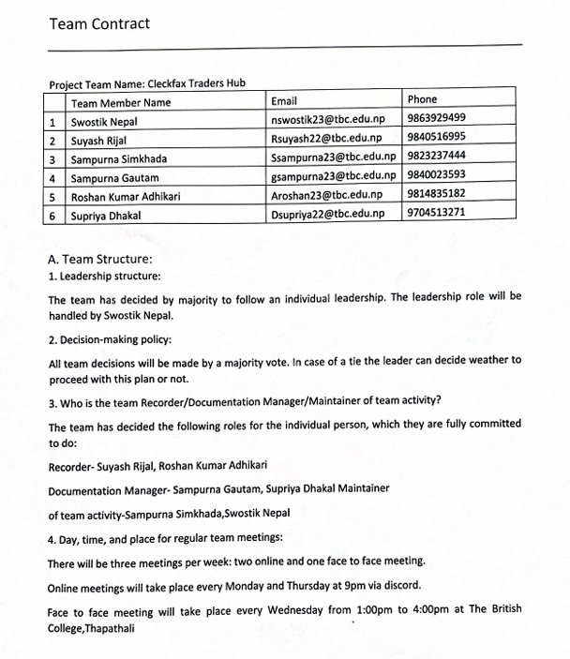

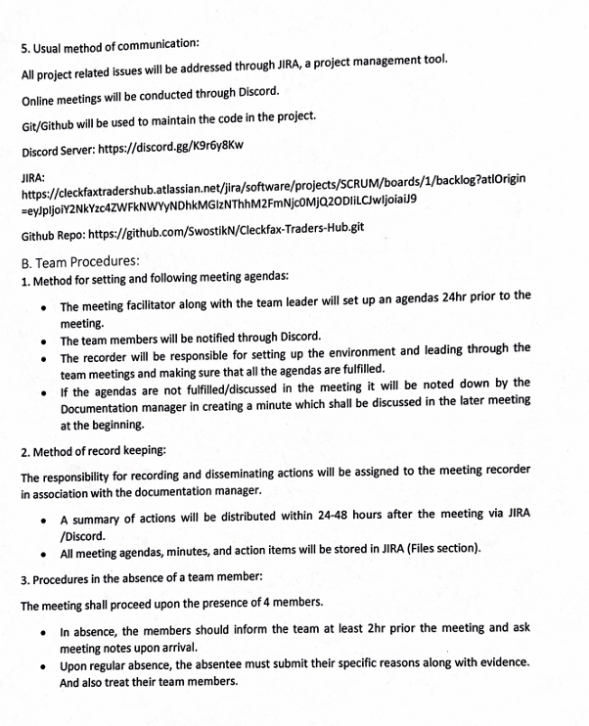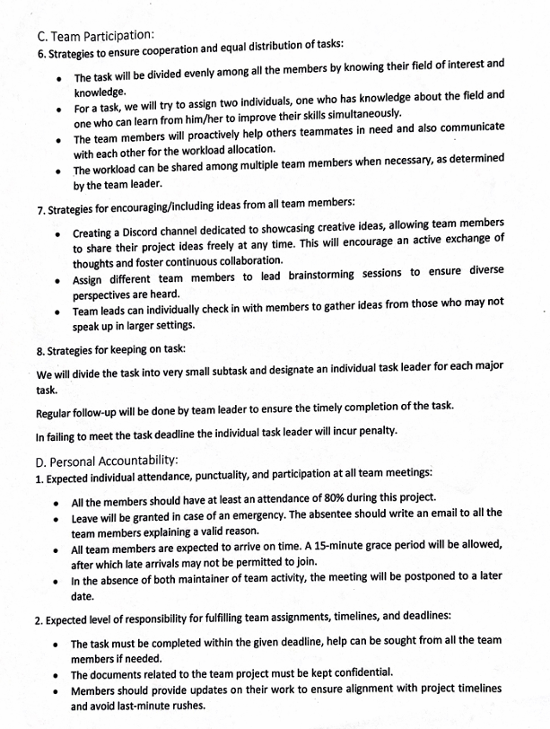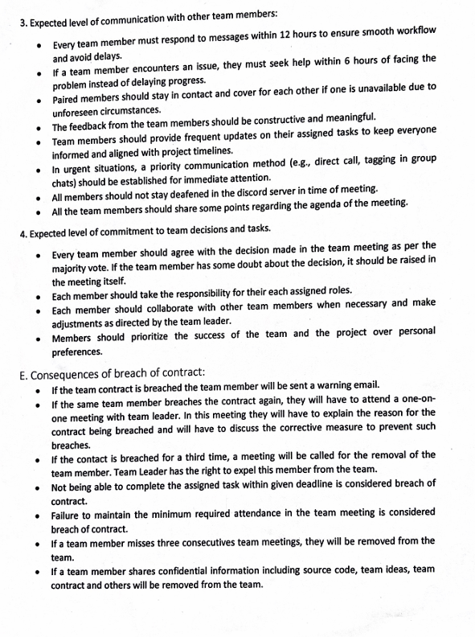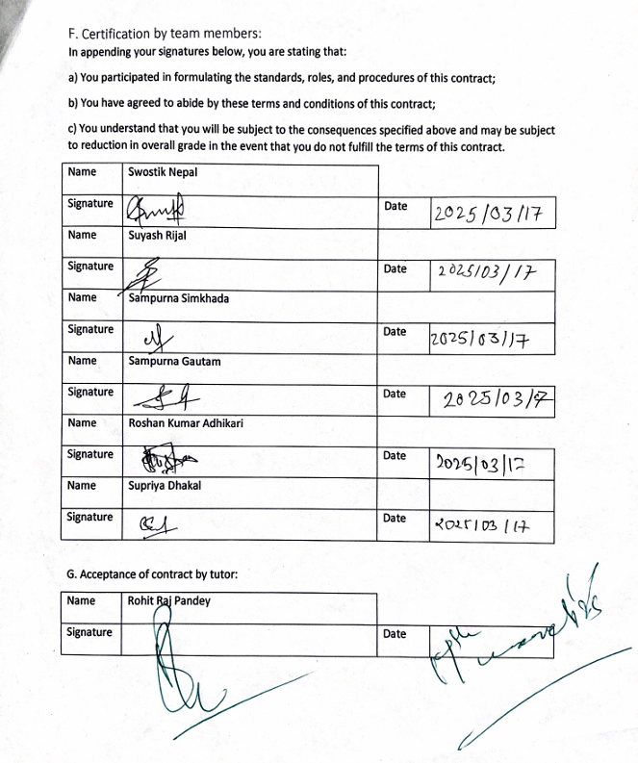

## Meeting Minutes

### Meeting 1:

Meeting agenda – discussion of project charter, team contract

Date- 3/12/2025  
Meeting outcome – division of work to team members

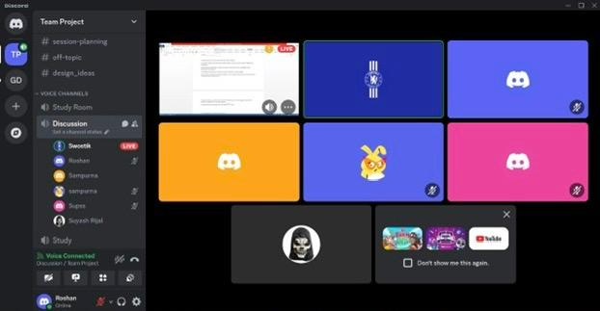

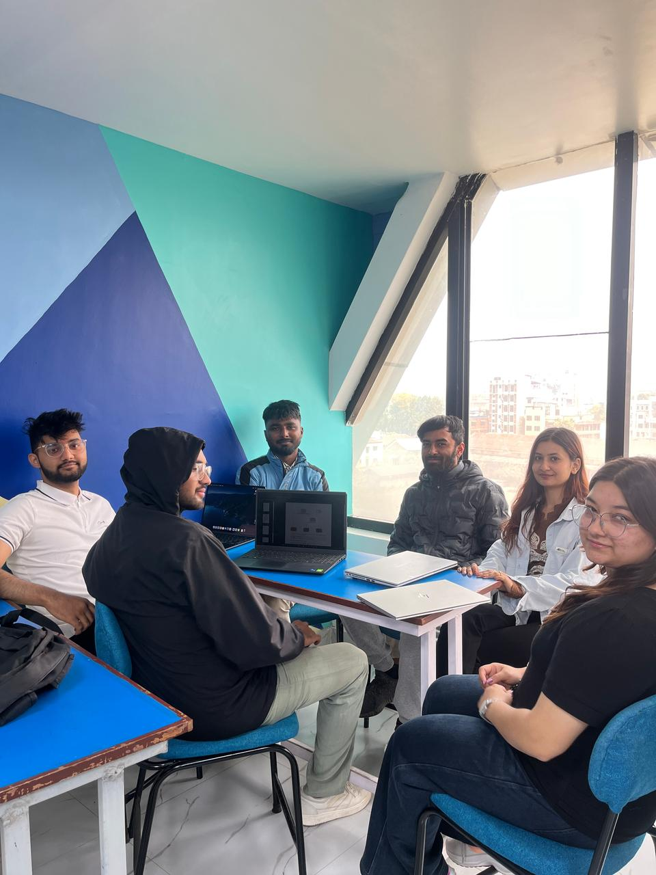

### Meeting 2:

Meeting agenda – finalizing of project character and team contract

Date-3/14/25

Meeting outcome-submission of project character and draft of team contract

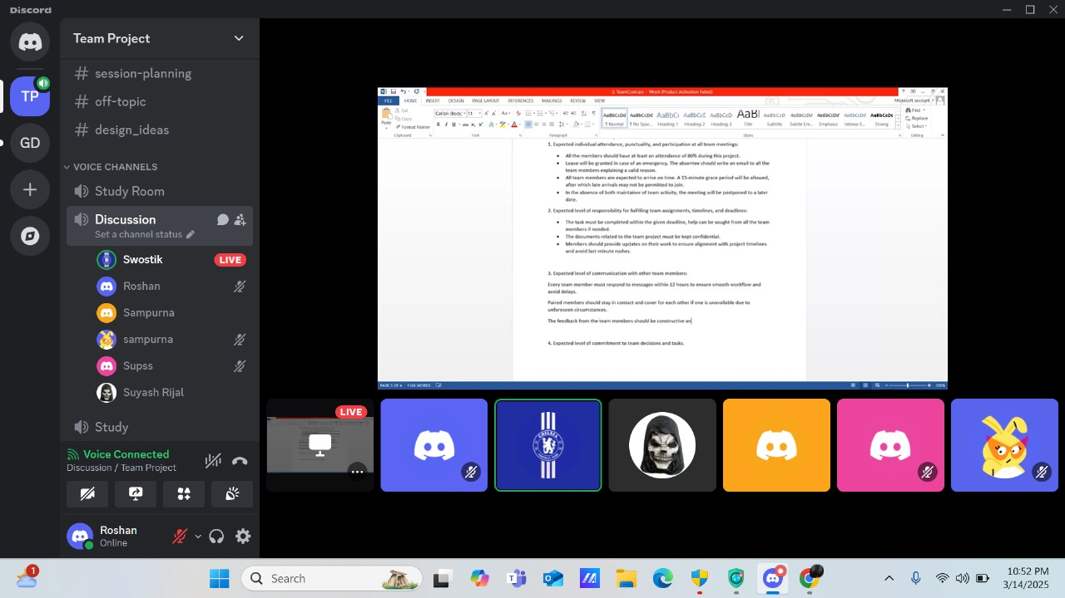

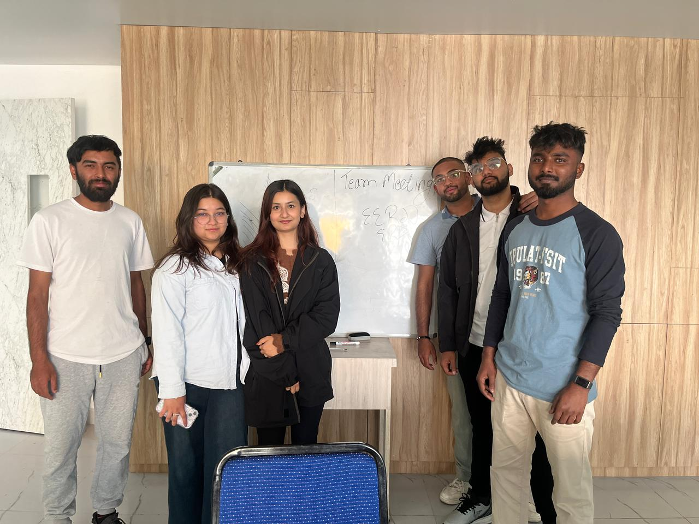

### Meeting 3

Meeting agenda – discussion of skill audit and Belbin analysis

Date- 3/19/2025

Meeting outcome – division of work to team members

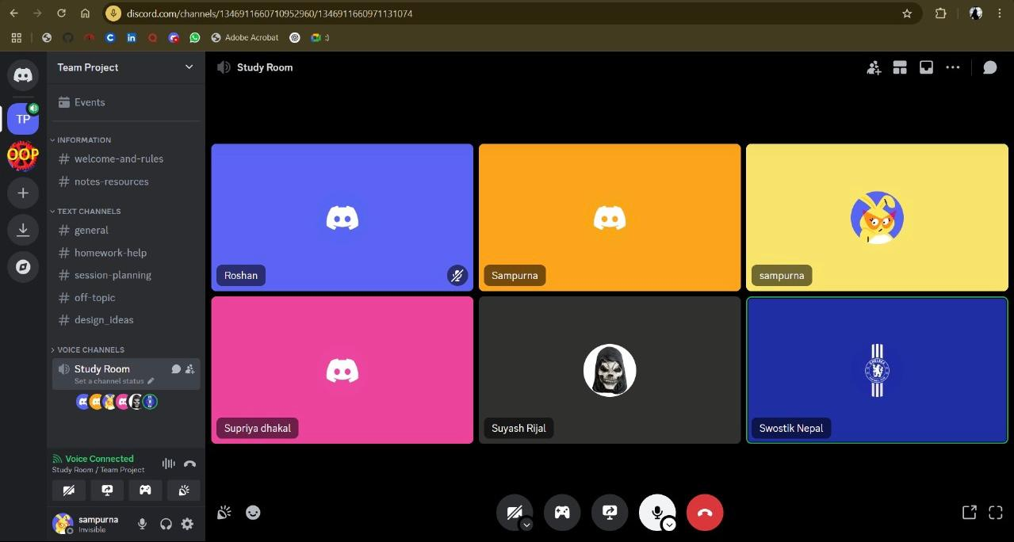

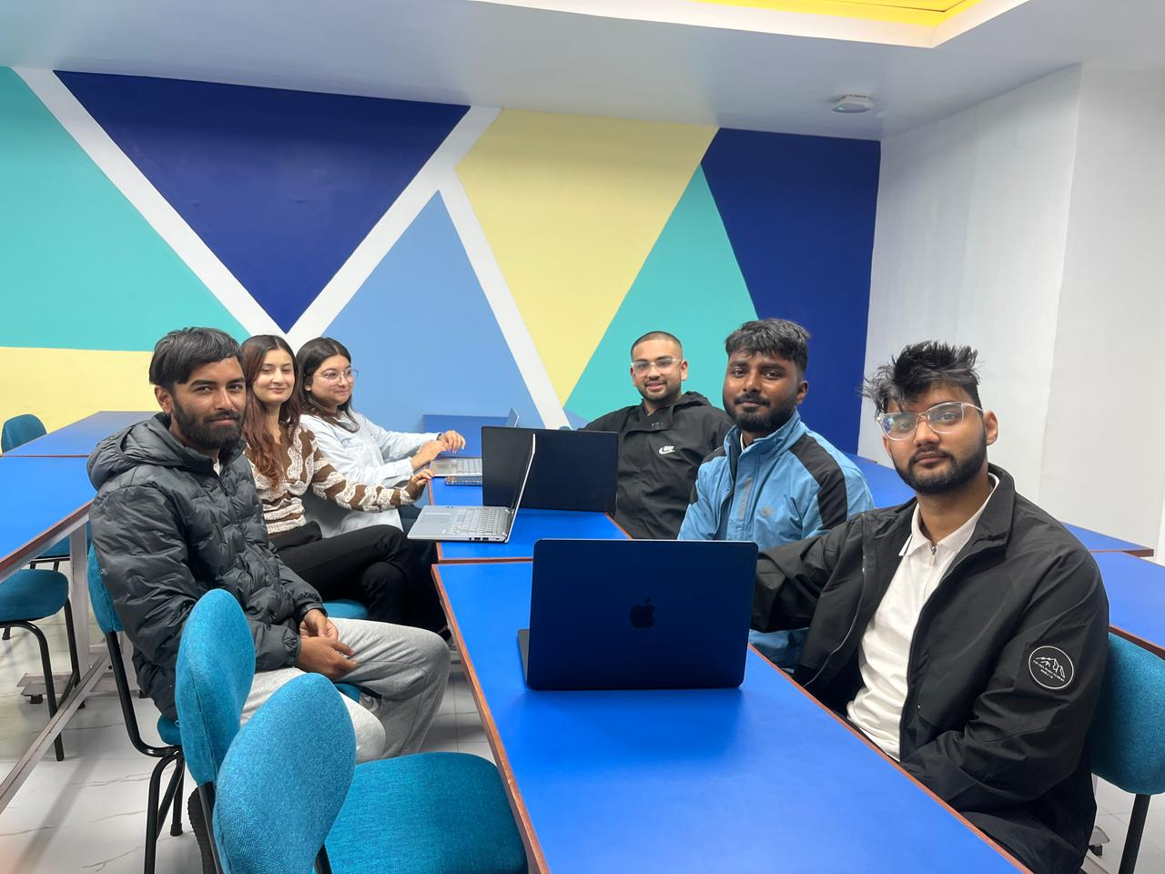

### Meeting 4

Meeting agenda – discussion of database part

Date- 31/3/2025

Meeting outcome – division of work to team members

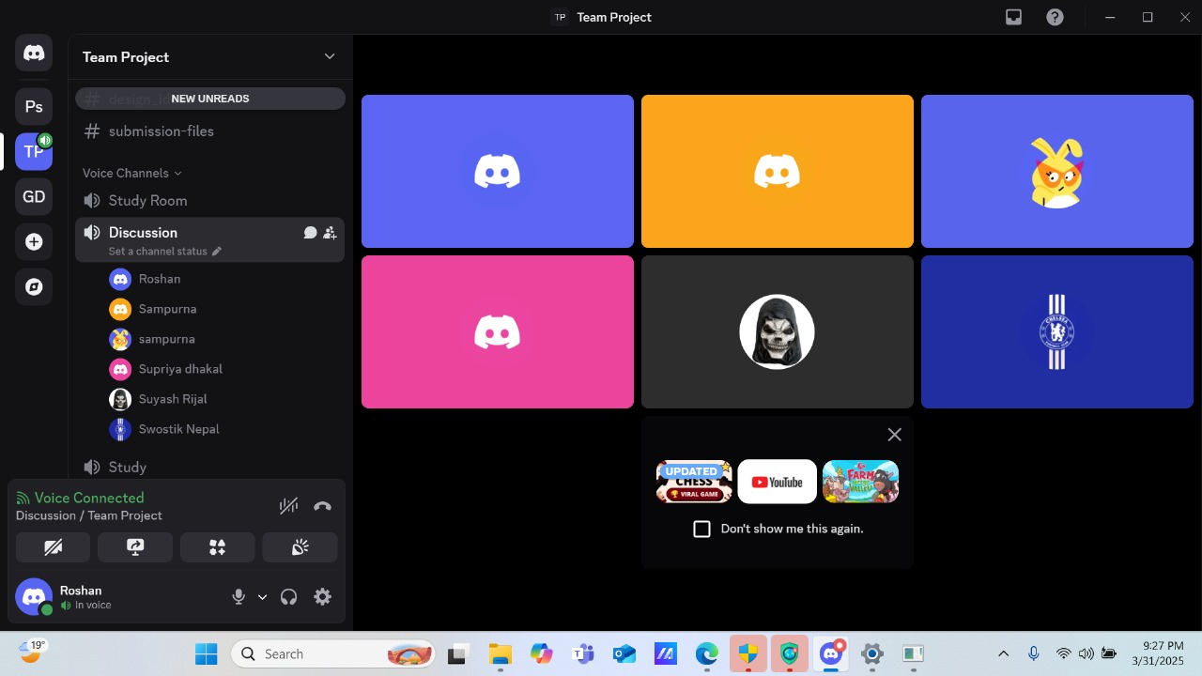

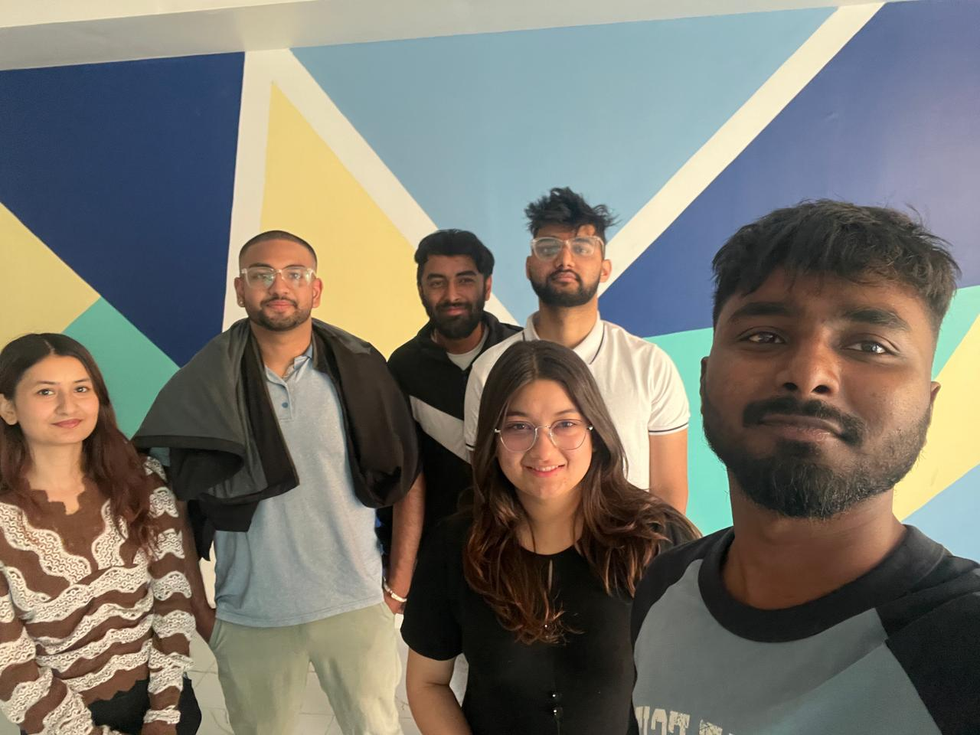

### Meeting 5

Meeting agenda – discussion of ERD, wireframe and logo

Date- 4/4/2025  
Meeting outcome – finalizing of database part, logo and prototype for wireframes

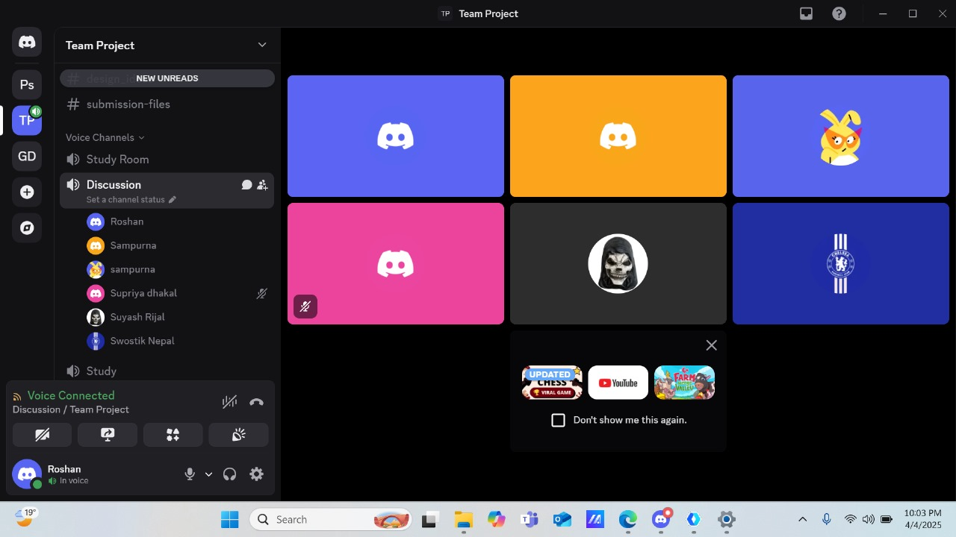

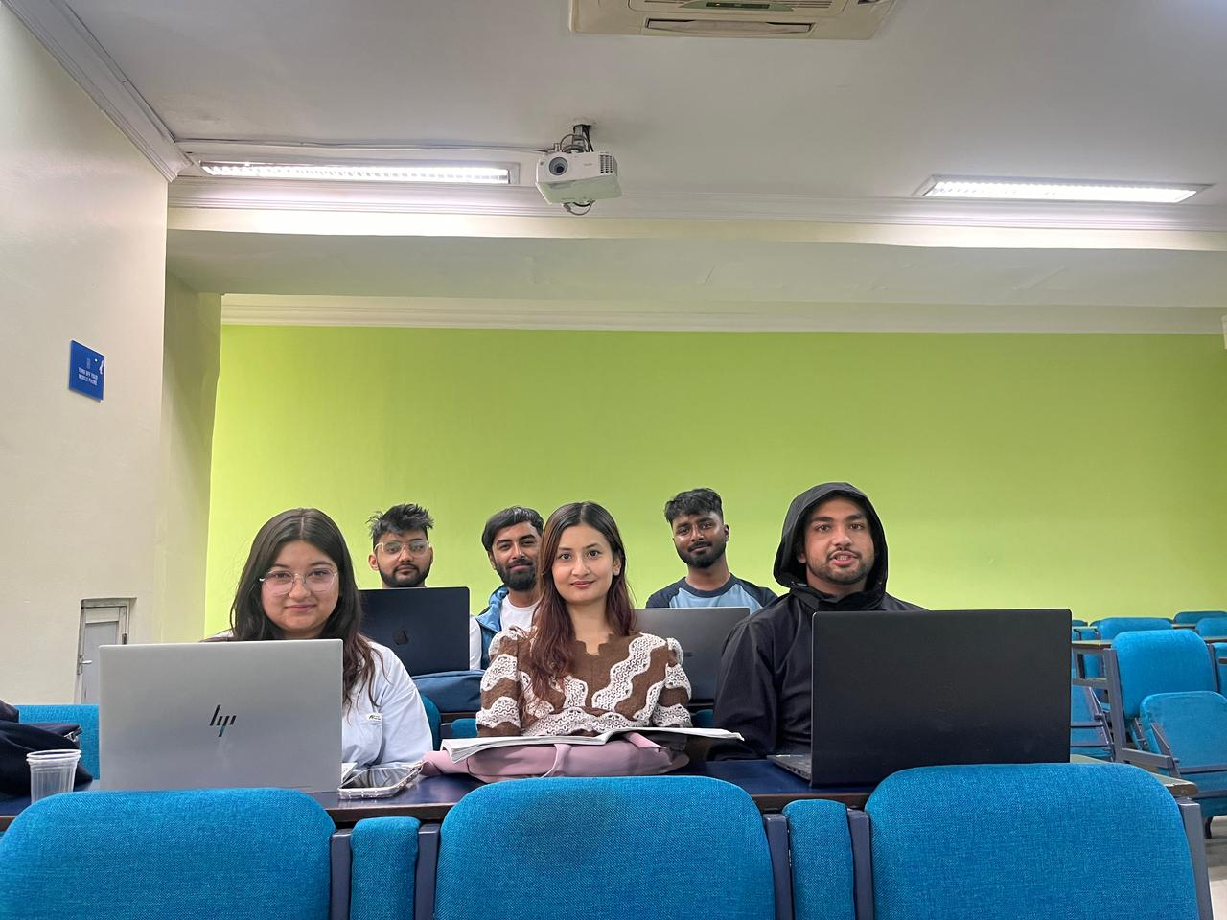

### Meeting 6

Meeting agenda – discussion of Ms.Project

Date- 7/4/2025  
Meeting outcome – division of work to team members

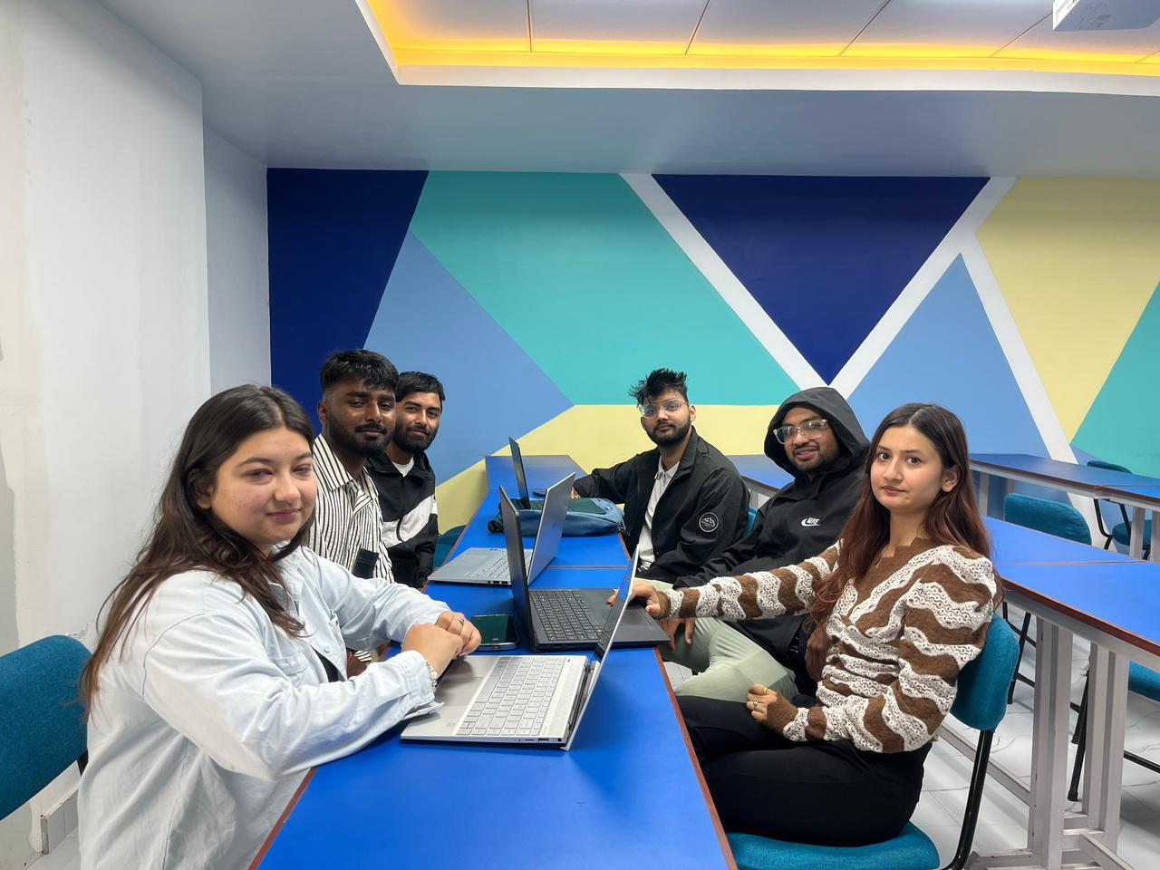

### Meeting 7

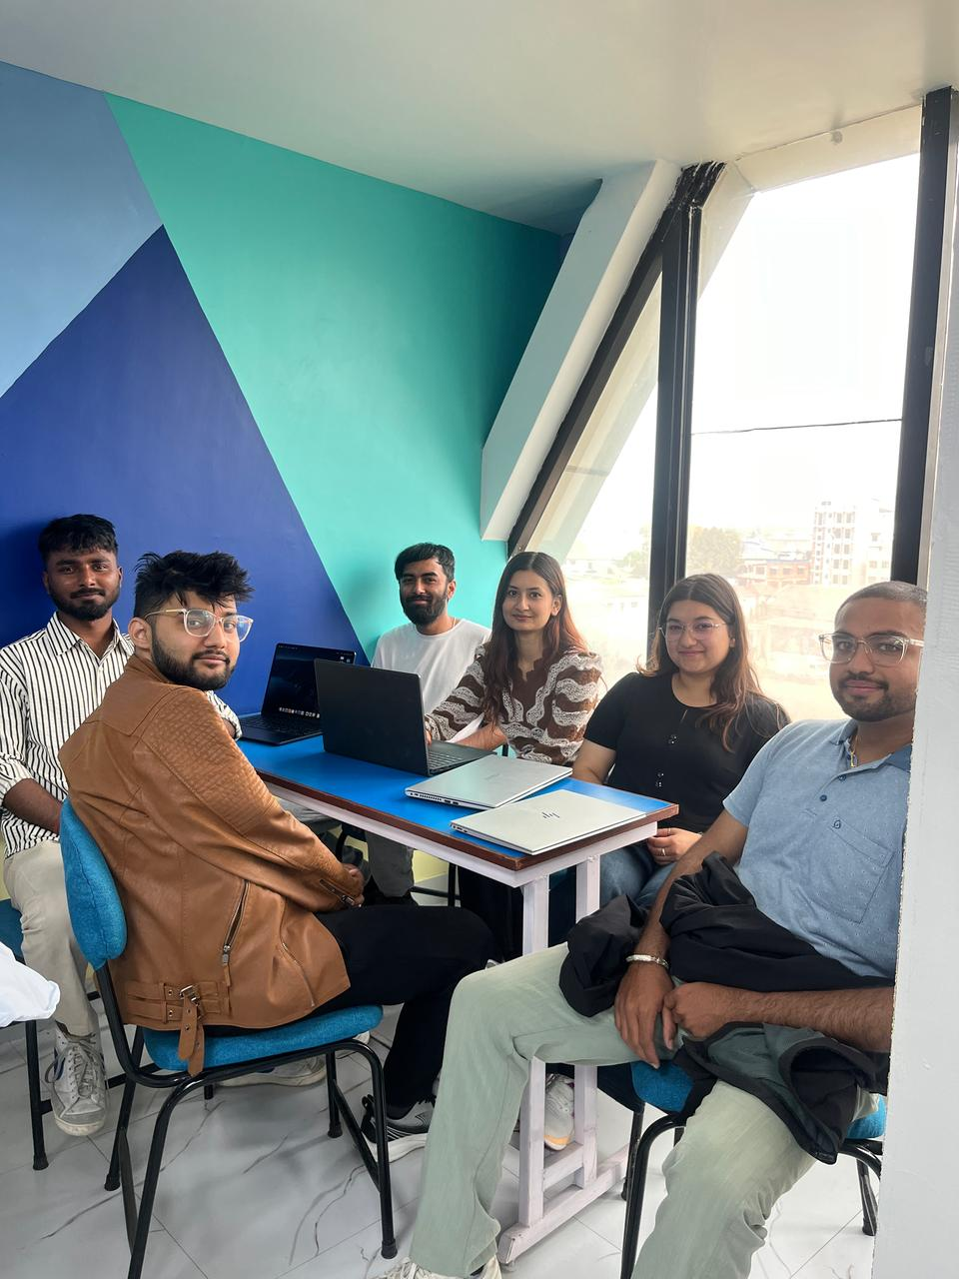

# **Planning Phase**

## Belbin Analysis

### Teams Belbin Analysis

**Team Members Name:**

Swostik Nepal

Suyash Rijal

Sampurna Gautam

Sampurna Simkhada

Supriya Dhakal

Roshan Kumar Adhikari

|  |  |  |
| --- | --- | --- |
| Version:1.0 **Belbin’s Analysis** Date reviewed: 3/21/2025 | | |
| Primary role | Swostik Nepal | Shaper |
| Suyash Rijal | Monitor Evaluator |
| Sampurna Simkhada | Team Worker |
| Sampurna Gautam | Monitor Evaluator |
| Supriya Dhakal | Team Worker |
| Roshan Kumar Adhikari | Plant |
| Secondary role | Swostik Nepal | Specialist |
| Suyash Rijal | Resource Investigator |
| Sampurna Simkhada | Specialist |
| Sampurna Gautam | Team Worker |
| Supriya Dhakal | Monitor Evaluator |
| Roshan Kumar Adhikari | Teamworker |
| Least likely role | Swostik Nepal | Resource Investigator |
| Suyash Rijal | Complete finisher |
| Sampurna Simkhada | Shaper |
| Sampurna Gautam | Shaper |
| Supriya Dhakal | Complete Finisher |
| Roshan Kumar Adhikari | Implementer |
| Do you think the descriptions of these roles are an accurate description of your behaviour in teams? How do you see yourself differently? | Swostik Nepal | Yes, these roles mostly align with my behavior, as I actively push teams forward and contribute my deep expertise, but I may rely on others for external networking. |
| Suyash Rijal | Yes, these roles do reflect me because I like to explore and analyze all the possibilities that are present before making a choice. Also, my second role as a resource investigator is appropriate for me since I prefer to come up with better and more effective ideas to choose from. |
| Sampurna Simkhada | Yes, these roles match my teamwork style. As a Team Worker, I focus on collaboration, supporting teammates, and creating a positive environment. I also take on the Specialist role by sharing my knowledge in specific areas. when it comes to the Shaper role, as I prefer to ensure that my team stays focused and productive. |
| Sampurna Gautam | Yes, these roles do reflect my behavior as I inspect the situation logically before providing any final decisions and consider all the possible outcomes and discuss with the team and do support all the team members which justifies my secondary role as well. |
| Supriya Dhakal | Yes, these are the roles that best describe me. As a Team Worker, I like being with people and keeping the team together. As a Monitor Evaluator, I think carefully before I act and view things logically. |
| Roshan Kumar  Adhikari | I think these roles fit me pretty well based on how I act in teams. As a Plant, I love coming up with new ideas and thinking outside the box—it’s something I enjoy and feel natural doing. I also see myself as a Teamworker because I like helping others and making sure everyone gets along. That said, I might see myself a bit differently when it comes to taking charge—I don’t always push my ideas hard, but I do try to share them in a way that keeps the group moving forward together. |
| Are there roles identified by Belbin that you might like to develop in yourself more? Which ones and why? | Swostik Nepal | I would like to develop the Completer Finisher role to improve my attention to detail, ensure high-quality work, and enhance my ability to meet deadlines with precision. |
| Suyash Rijal | Yes, I would like to further enhance my completer-finisher skills since it will assist me in preventing the hassle of going through a whole codebase again because of a tiny error later in my career |
| Sampurna Simkhada | I want to improve as a Monitor Evaluator to make better logical decisions. I also want to develop my Implementer skills to turn ideas into clear action plans. Strengthening these roles will help me contribute more strategically and efficiently while maintaining my strengths in teamwork and expertise. |
| Sampurna Gautam | Yes, I would like to develop the complete finisher as it teaches me different kinds of skills like persistence, organizational skills, patience and others . |
| Supriya Dhakal | Yes, I would like to develop complete finisher as I miss the details more frequently. By improving this skill it will help me make my work more polished. |
| Roshan  Kumar  Adhikari | I’d like to work on my Plant role a bit more. Being creative is fun, but I want to get better at explaining my ideas clearly so the team can use them easily. I also think growing as a Teamworker would help me support my teammates even more—maybe by listening better or stepping up when someone needs a hand. It’d make me more useful to the group and help us do better overall. |
| What possible situations in the coming months can you identify where you could work on developing these skills? | Swostik Nepal | I can develop my Completer Finisher skills by ensuring precision and meeting deadlines in my ecommerce website project and team project at university. |
| Suyash Rijal | I would likely take on some personal courses with time constraints and gain experience by working in some projects besides this team project. |
| Sampurna Simkhada | I could develop these following skills in the brainstorming parts of our project. Generating creative ideas, thinking outside of the box for unique problem solving. Exploring and experimenting with one-of-a-kind concepts in the team project’s meetings and workshops. Collaborating with team members for their insights as well as strengthening team bonds. |
| Sampurna Gautam | I can develop my skills by proper working with my team mates , taking parts in more group works and also seek helps from my team mates . |
| Supriya Dhakal | I would probably work on more group projects in upcoming future which would also enhance my completer finisher skill. |
| Roshan  Kumar  Adhikari | With the Cleckfax Traders Hub project coming up, I’ll get chances to practice. I can share new ideas in brainstorming and explain them clearly. In meetings and planning, I’ll help out, keep it friendly, and make sure everyone’s heard. Presentations will let me try both roles.  . |
| Considering your team working, how do you think you could improve your effectiveness in group work and in contributing to the success of teams that you work in? | Swostik  Nepal | I can improve my effectiveness in group work by taking on more responsibility for external networking and idea generation, refining my Resource Investigator skills, and ensuring I support team members by maintaining high standards and attention to detail. |
| Suyash Rijal | Effective communication is the cornerstone of any team. By openly expressing our thoughts while respecting other people's views, we can build a team culture where varied options are valued, leading to an unbiased successful team. |
| Sampurna Simkhada | I can be more proactive in discussions, help ensure tasks are completed on time, and give constructive feedback. By balancing teamwork with better execution and decision-making, I can contribute more effectively to the team's success. |
| Sampurna Gautam | I can boost my effectiveness by combining critical thinking with proactive action. By engaging more in discussions, taking responsibility for tasks, and assisting in resolving conflicts, I can improve both teamwork and overall productivity. |
| Supriya Dhakal | I would improve the effectiveness of my group by making sure that the deadlines are met on time and also ask for feedback with my team members which will also help me to improve my approach. |
| Roshan  Kumar Adhikari | To get better in group work, I want to focus on sharing my creative ideas in a way that’s easy for everyone to grab onto. I could also work on being more patient and listening to what others think, so we can mix all our ideas into something strong. Staying positive and jumping in to help when things get tricky would also make me a bigger part of the team’s success. |
| Are the results of this inventory consistent with how you worked in the Foundation Project in your small groups for discussions and presentations? | Swostik Nepal | Yes, the results of the Belbin inventory are consistent with how I worked in the Foundation Project, as I took charge in driving discussions forward and focused on presenting technical aspects and detailed knowledge during presentations. |
| Suyash Rijal | Yes, the results of this project were congruent. I have also been able to complete other team projects, and the results of this inventory are congruent with those of my foundation project. |
| Sampurna Simkhada | I believe my approach to small group work is compatible with my Foundation Project experience and the inventory results. In my experience, I have tried to make a meaningful addition to the discussion and presentation by actively engaging with our team members, exchanging ideas, and collaborating to reach our goals. |
| Sampurna Gautam | Indeed, the results align with my experience in the Foundation Project. I frequently analyzed various perspectives before making decisions and collaborated closely with my team. However, I occasionally hesitated to take the lead, which corresponds with my least likely Shaper role. |
| Supriya Dhakal | Yes, the results of this project were consistent. We, teammates had a good communication which helped us to do the project in a efficient way. |
| Roshan  Kumar  Adhikari | Yeah, it fits. In the Foundation Project, I shared new ideas in talks, like a Plant. I kept the group happy and working together, like a Teamworker. |
| How well do you want to contribute to group presentations? | Swostik Nepal | I want to contribute to group presentations by providing in-depth technical insights, ensuring accuracy and clarity in my section, and helping drive the overall narrative to align with the team’s goals. |
| Suyash Rijal | Since the presentation is the final hurdle in our project journey, I wish to return to it all that I have gained and all that I will gain throughout this production project. |
| Sampuna Simkhada | I’m eager to play a key role in group presentations. I want to help the team stay organized, share well-researched insights, and ensure the presentation is engaging and impactful. |
| Sampurna Gautam | I aim to contribute by making sure the presentation is logically organized, thoroughly researched, and clearly presented. I will assist my team by offering valuable insights, structuring the content, and helping to clarify and strengthen key points for greater impact. |
| Supriya Dhakal | I would like to contribute by supporting my teammates in refining their parts and taking responsibility for structuring the group presentation. |
| Roshan  Kumar  Adhikari | I really want to shine in group presentations. I’d love to come up with cool ideas for the content and help shape how we present it. I’ll also chip in by supporting my teammates—maybe practicing with them or giving feedback. |

## Skill Audit

### Team’s Skill Audit

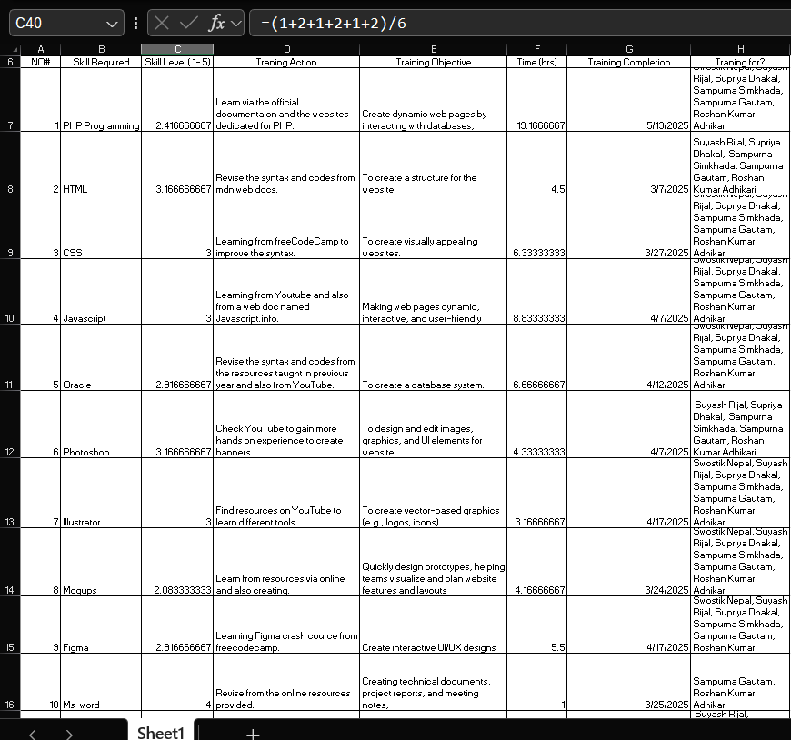

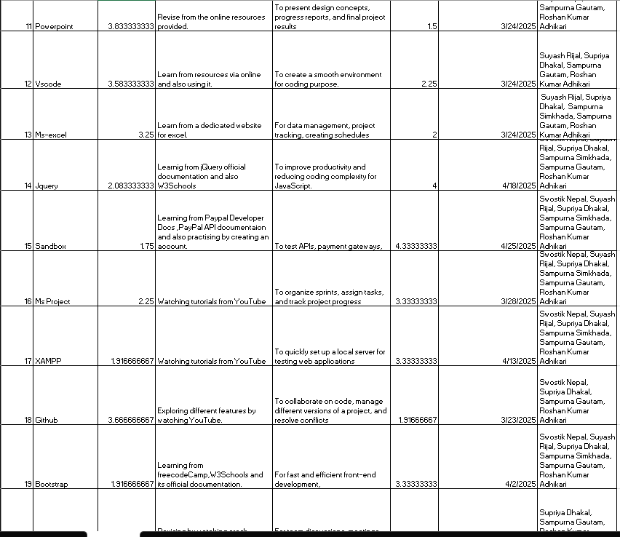

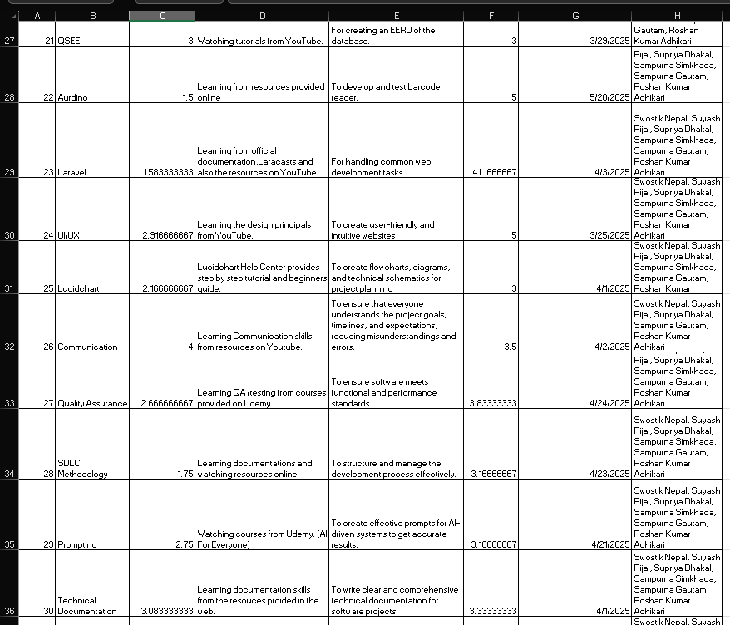

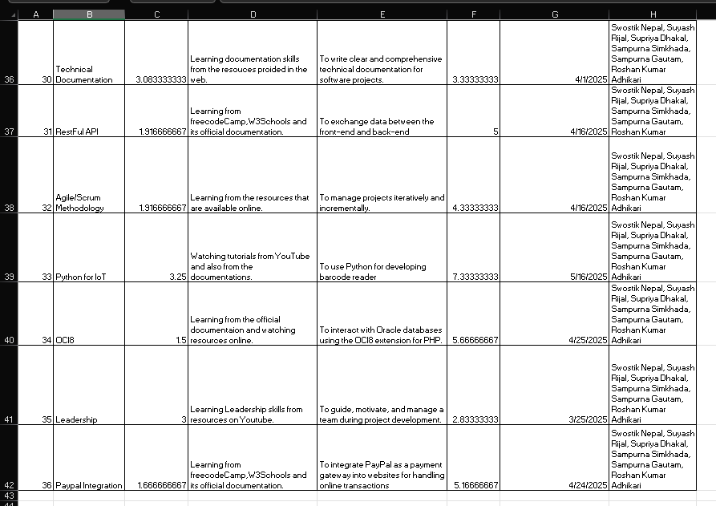

## Project Management

### Gantt Chart 1

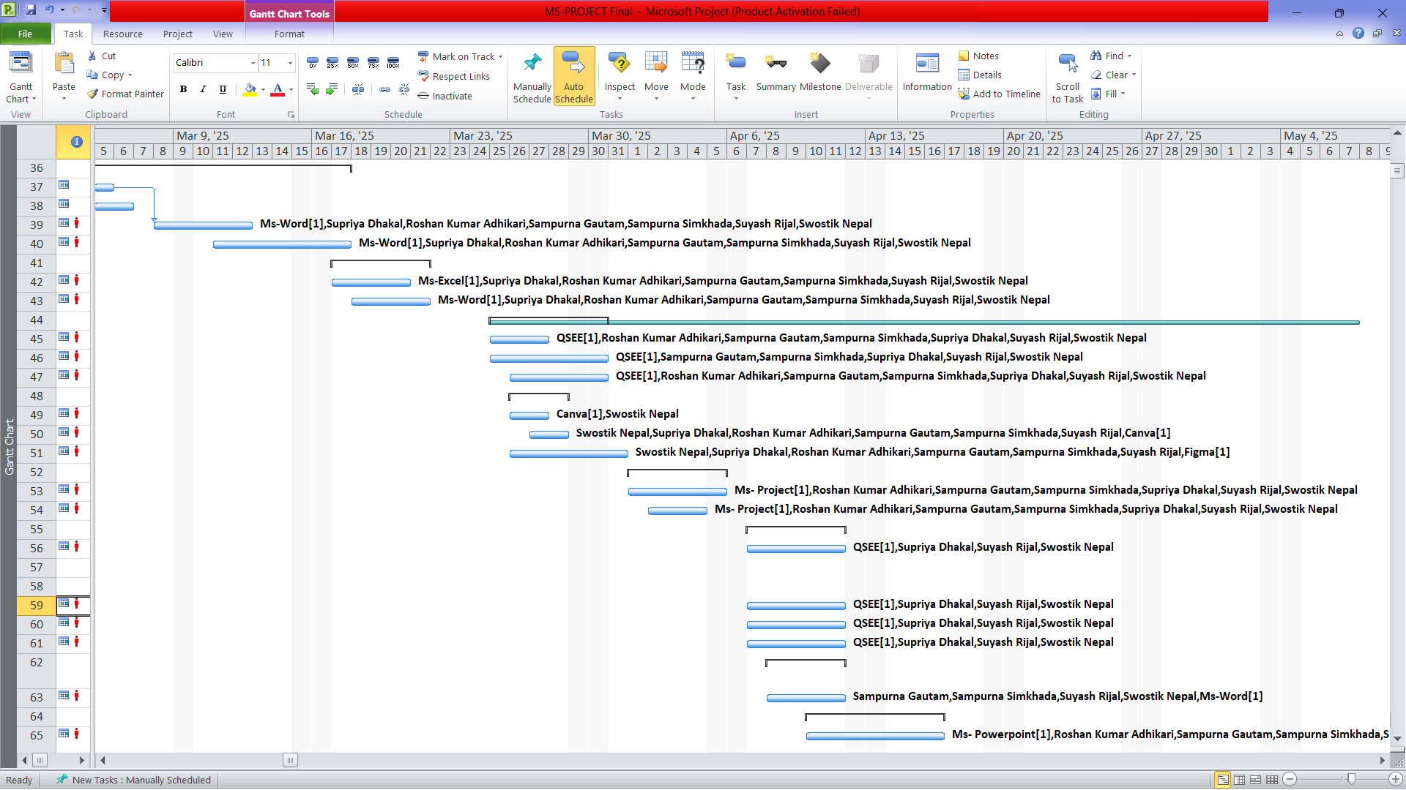

### Gantt Chart 2

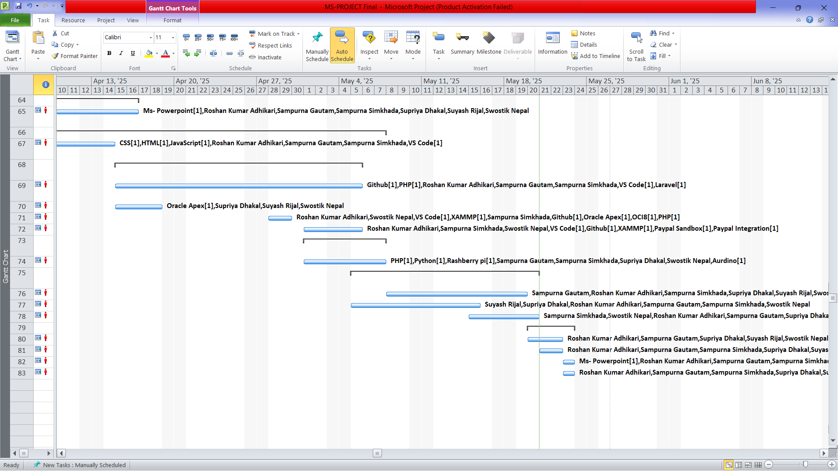

### Task Sheet 1

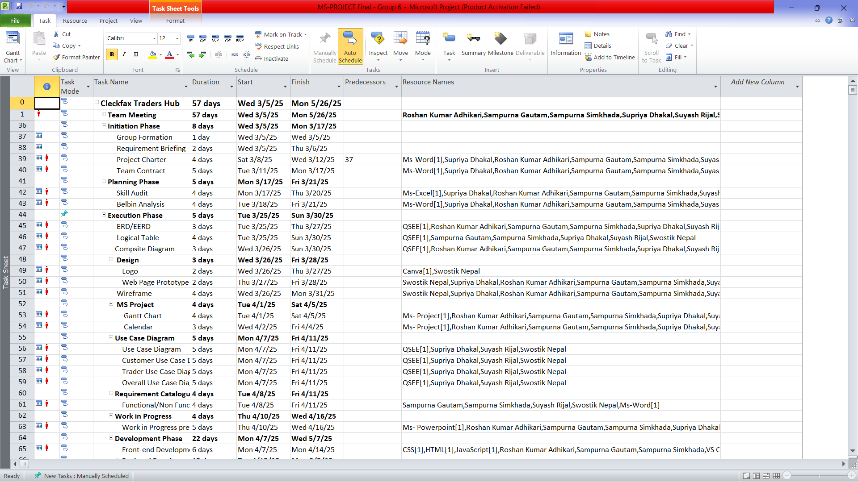

### Task Sheet 2

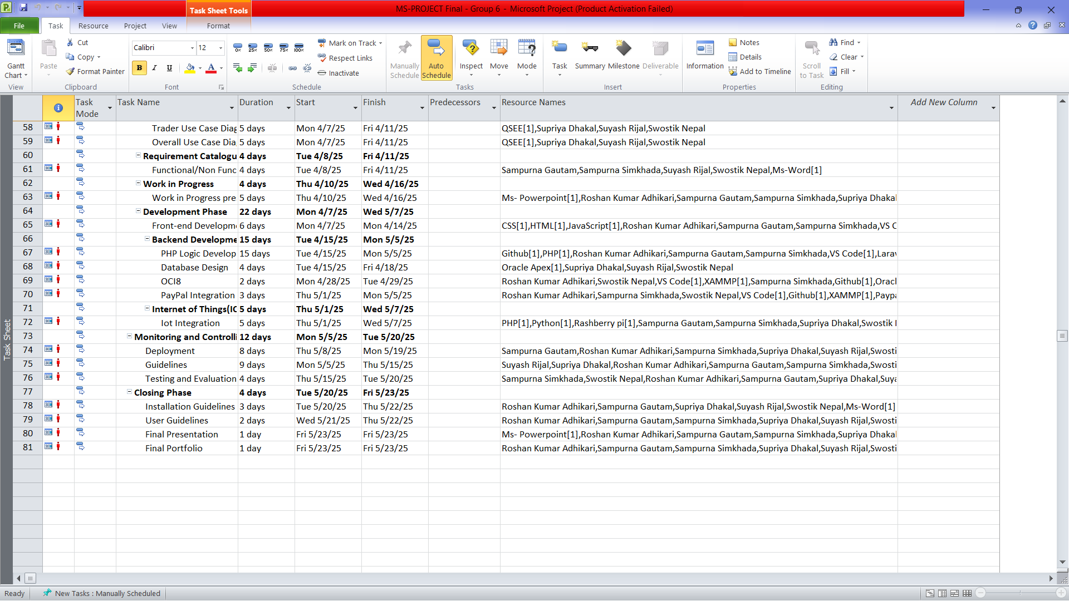

### Timeline

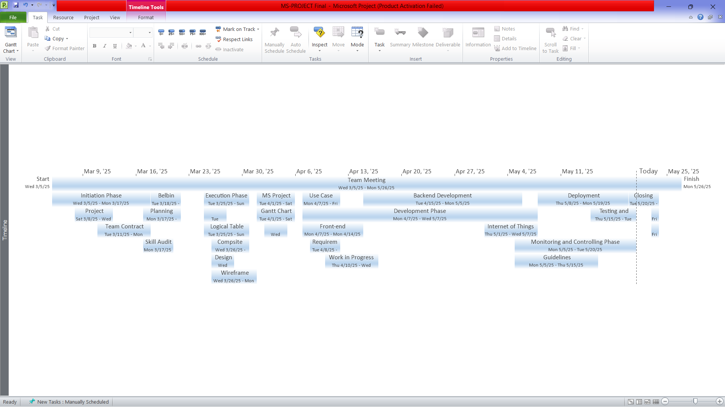

### Calendar 1

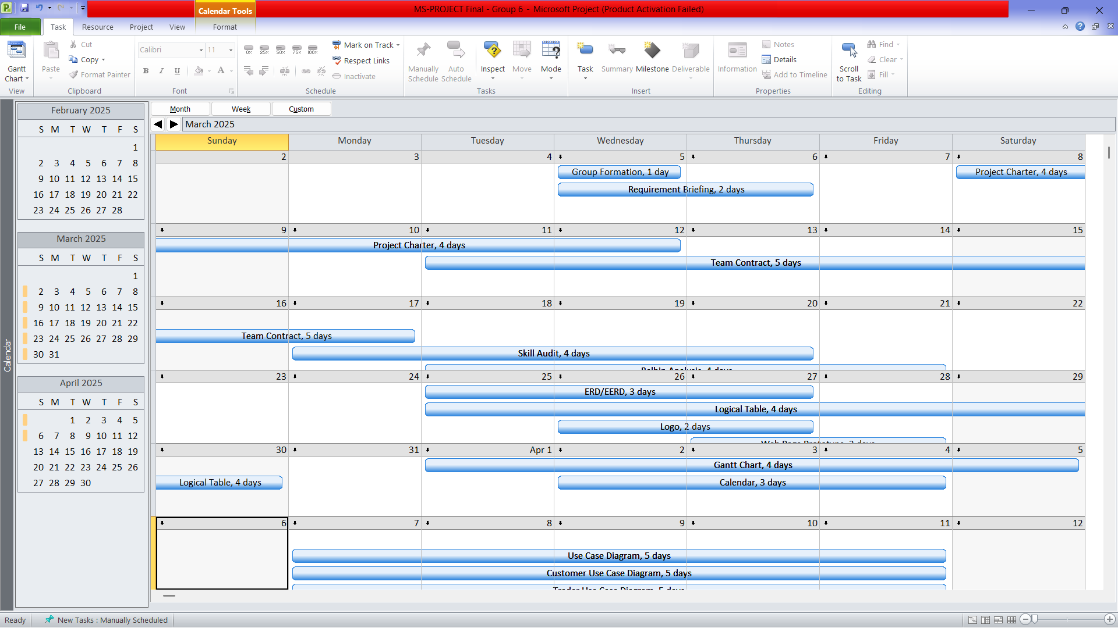

### Calendar 2

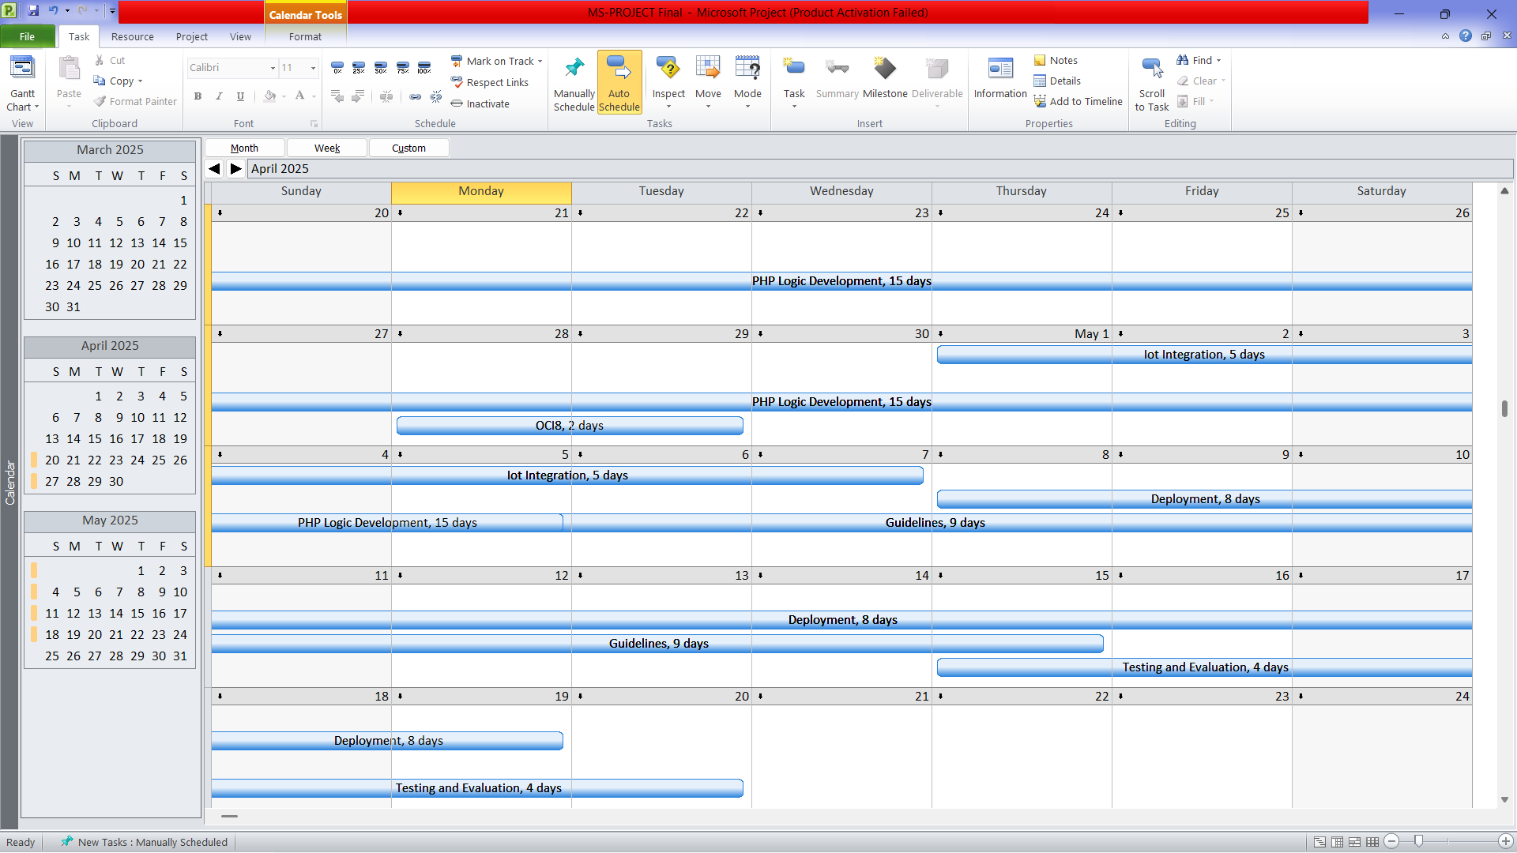

### Resource Sheet 3.1

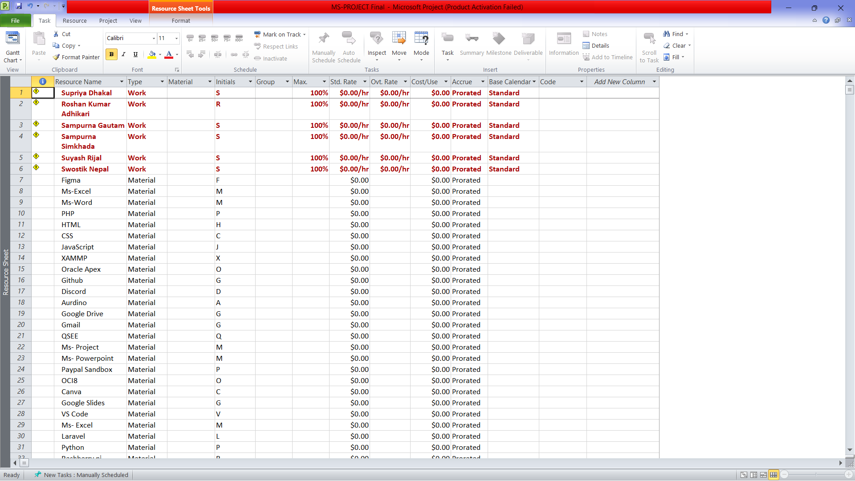

### Resource Sheet 3.2

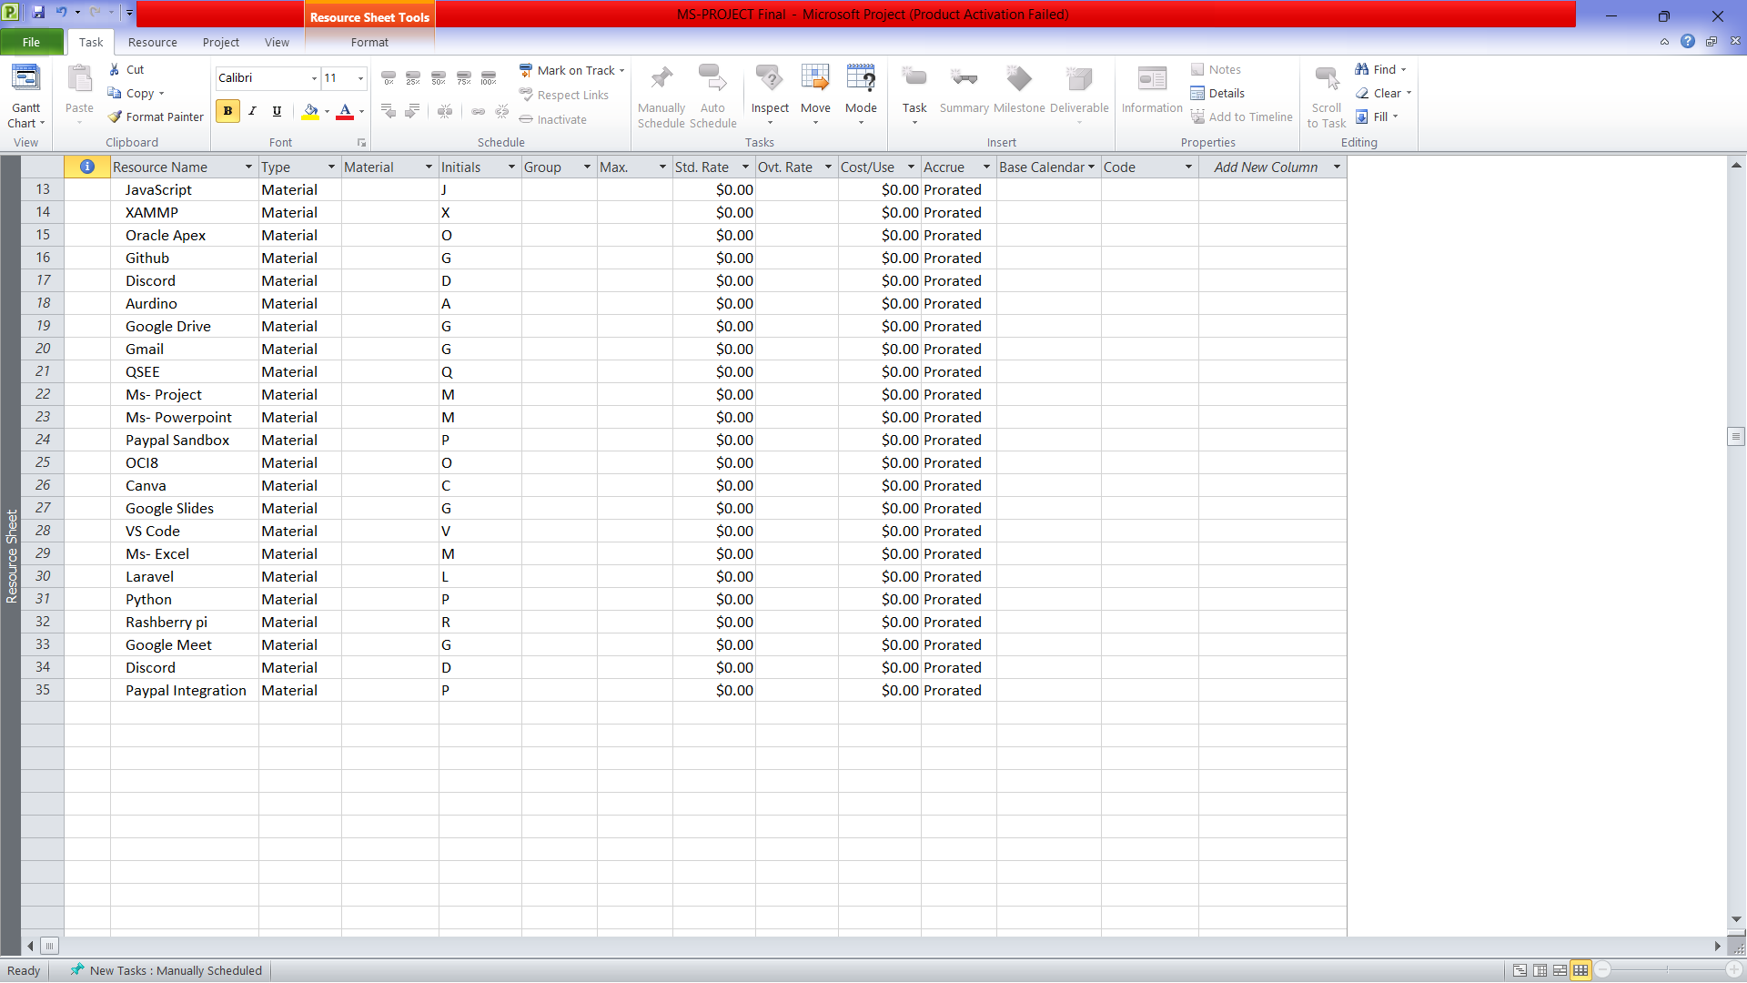

### Calendar Working Hour

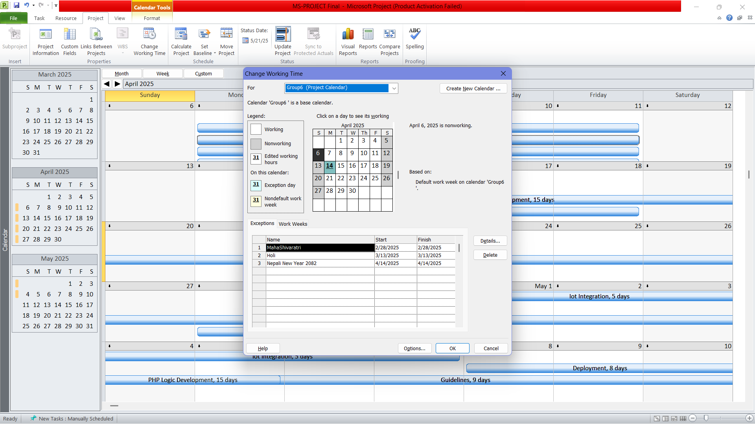

## Communication Tool Used

### Discord Chats

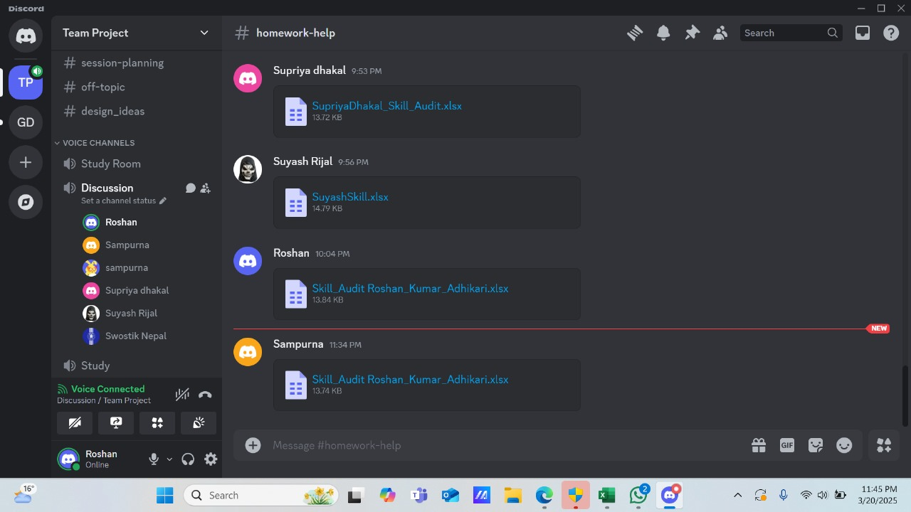

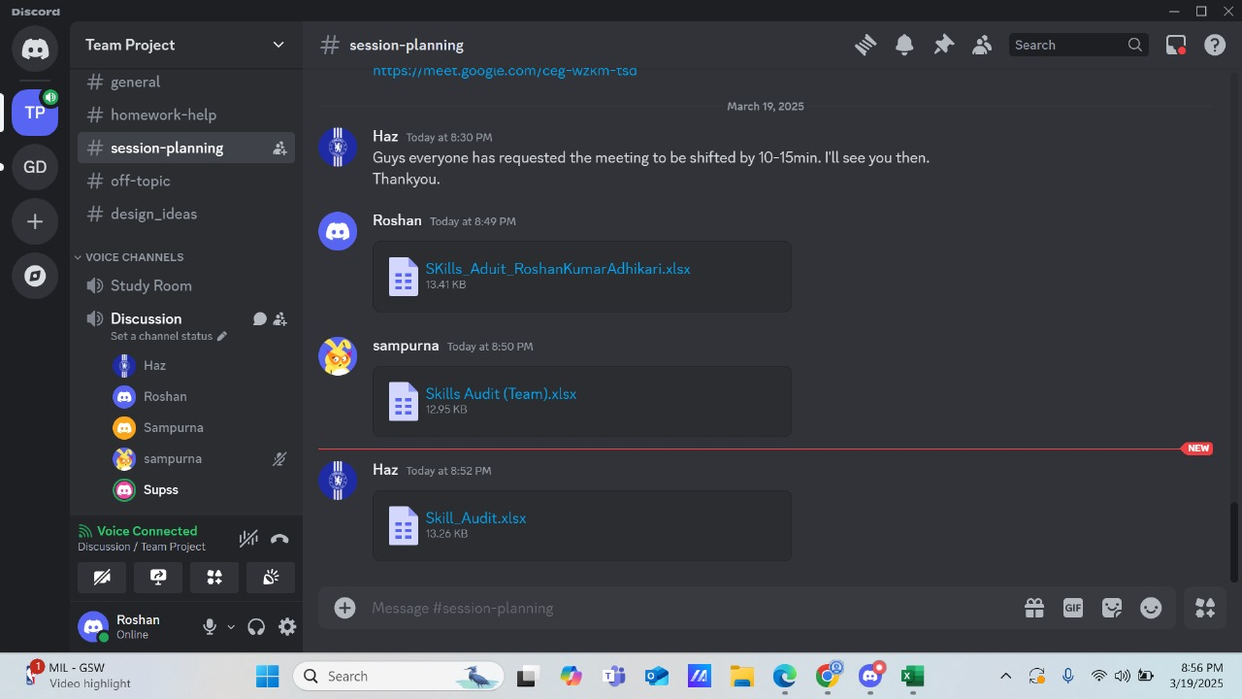

### GitHub

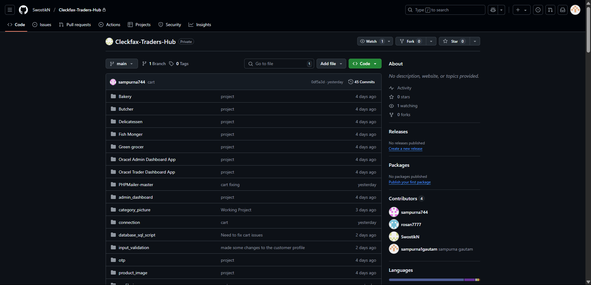

# **. Execution**

## Entity Relationship Diagram

### Extended Entity Relationship Diagram (EERD)

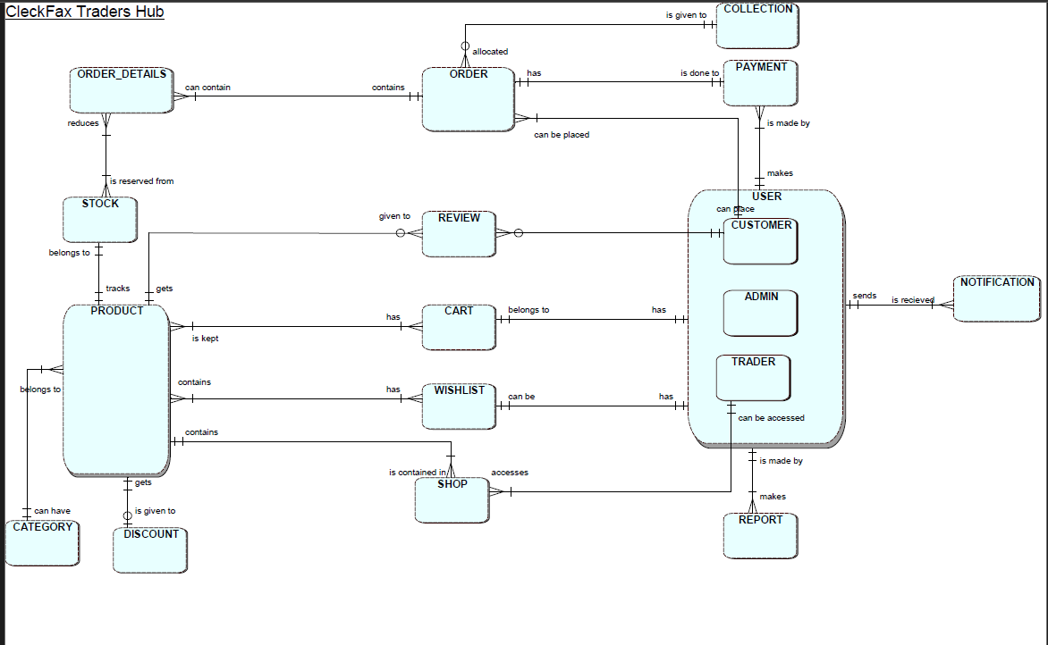

### Entity Relationship Diagram (ERD)

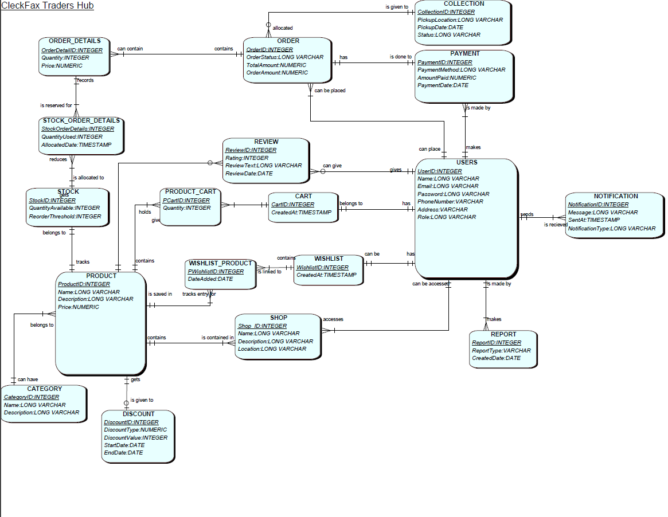

## Composite Model

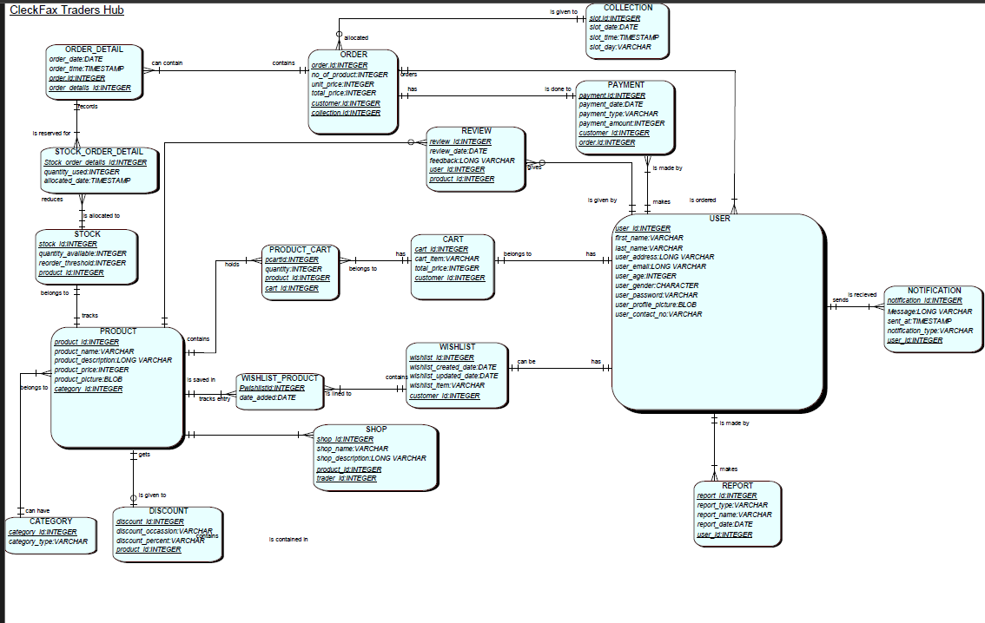

## Logical Design

**User Entities**

1. **USER** (**user_id**, first_name, last_name, user_address, user_email, user_age, user_gender, user_password, user_profile_picture, user_contact_no)
2. **CUSTOMER** (***user_id***, customer_date_joined, verification_code, date_updated, profile_picture)
3. **TRADER** (***user_id,*** trader_type, shop_name, profile_picture)
4. **ADMIN** (***user_id)***

**Product & Inventory Entities**

1. **CATEGORY** (**category_id**, category_type)
2. **PRODUCT** (**product_id**, product_name, product_description, product_price, product_picture, *category_id*)
3. **STOCK** (**stock_id**, quantity_available, reorder_threshold, *product_id*)

**Order & Shopping Entities**

1. **CART** (**cart_id**, cart_item, total_price, *customer_id*)
2. **PRODUCT_CART** (**pcart_id**, quantity, *product_id*, *cart_id*)
3. **WISHLIST** (**wishlist_id**, wishlist_created_date,wishlist_item, wishlist_updated_date, *customer_id*)
4. **WISHLIST_PRODUCT** (**pwishlist_id**, date_added, *product_id*, *wishlist_id*)
5. **COLLECTION** (**slot_id**, slot_date, slot_time, slot_day)
6. **ORDER** (**order_id**, order_time, no_of_product, unit_price, total_price, *customer_id*, *collection_id*)
7. **ORDER_DETAILS** (**order_detail_id**, *order_id*)
8. **STOCK_ORDER_DETAILS** (**stock_order_details_id**, quantity_used, allocated_date, *stock_id*, *order_detail_id*)

**Payment & Review Entities**

1. **PAYMENT** (**payment_id**, payment_date, payment_type, payment_amount, *customer_id*, *order_id*)
2. **REVIEW** (**review_id**, review_date, feedback, *user_id*, *product_id*)

**Shop & Promotion Entities**

1. **SHOP** (**shop_id** ,shop_name, shop_description, *trader_id, product_id*)
2. **DISCOUNT** (**discount_id**, discount_occasion, discount_percent, *product_id*)

**Support & Notification Entities**

1. **REPORT** (**report_id**, report_type, report_name, report_date, *user_id*)
2. **NOTIFICATION** (**notification_id**, message, sent_at, notification_type, *user_id*)

## Logical Table

|  |  |  |  |
| --- | --- | --- | --- |
| Entity | Primary Key | Attributes | Foreign Key |
| USER | user_id | first_name, last_name, user_address, user_email, user_age, user_gender, user_password, user_profile_picture, user_contact_no | - |
| CUSTOMER | user_id | customer_date_joined, verification_code, date_updated, profile_picture | user_id |
| TRADER | user_id | trader_type, shop_name, profile_picture | user_id |
| ADMIN | user_id | - | user_id |
| CATEGORY | category_id | category_type | - |
| PRODUCT | product_id | product_name, product_description, product_price, product_picture | category_id |
| STOCK | stock_id | quantity_available, reorder_threshold | product_id |
| CART | cart_id | cart_item, total_price | customer_id |
| PRODUCT_CART | pcart_id | quantity | product_id, cart_id |
| WISHLIST | wishlist_id | wishlist_created_date, wishlist_item, wishlist_updated_date | customer_id |
| WISHLIST_PRODUCT | pwishlist_id | date_added | product_id, wishlist_id |
| COLLECTION | slot_id | slot_date, slot_time, slot_day | - |
| ORDER | order_id | order_time, no_of_product, unit_price, total_price | customer_id, collection_id |
| ORDER_DETAILS | order_detail_id | - | order_id |
| STOCK_ORDER_DETAILS | stock_order_details_id | quantity_used, allocated_date | stock_id, order_detail_id |
| PAYMENT | payment_id | payment_date, payment_type, payment_amount | customer_id, order_id |
| REVIEW | review_id | review_date, feedback | user_id, product_id |
| SHOP | shop_id | shop_name, shop_description | trader_id, product_id |
| DISCOUNT | discount_id | discount_occasion, discount_percent | product_id |
| REPORT | report_id | report_type, report_name, report_date | user_id |
| NOTIFICATION | notification_id | message, sent_at, notification_type | user_id |

## Use Case Model

### Overview Use Case Diagram

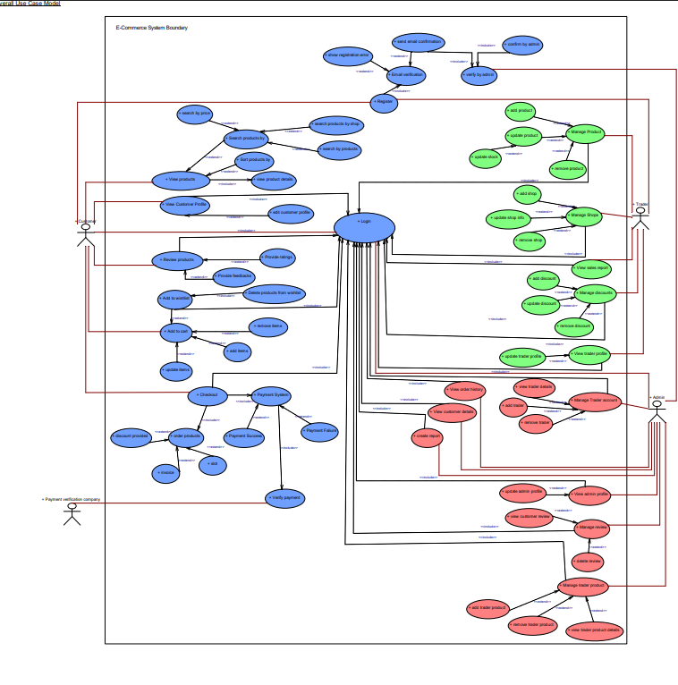

### Customer Use Case Diagram

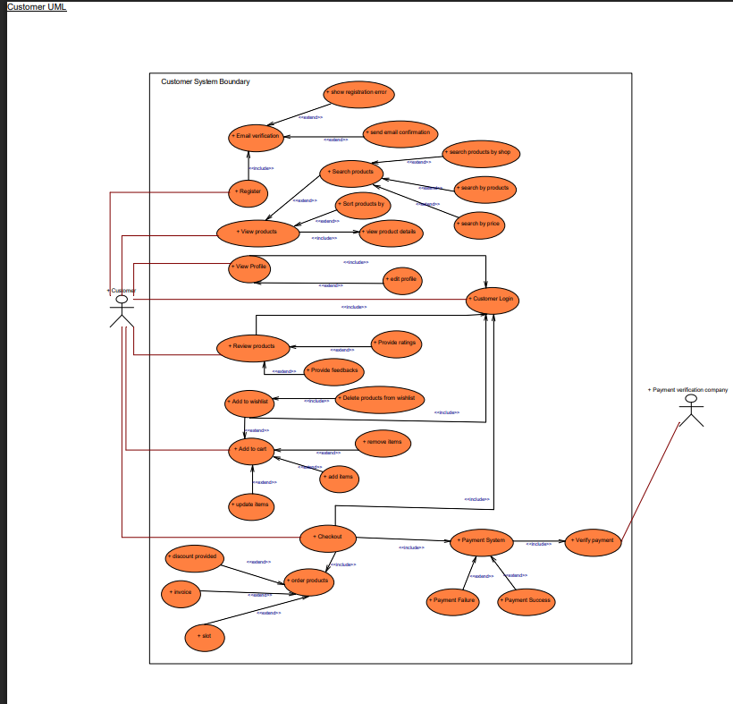

### Trader Use Case Diagram

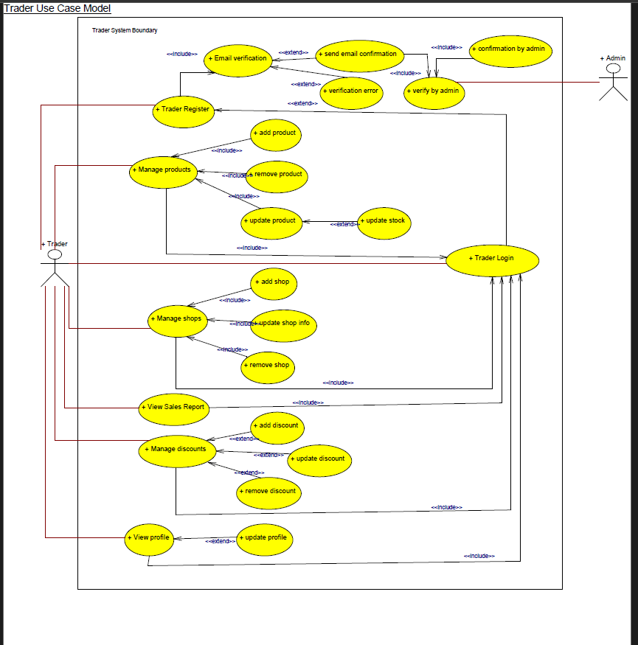

### Admin Use Case Diagram

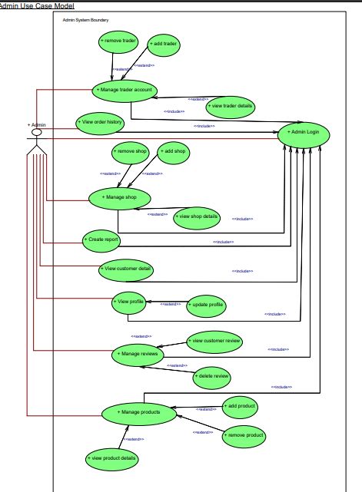

## Requirement Catalogue

### Functional Requirements:

* + **A: Product**

|  |  |  |
| --- | --- | --- |
| **Requirement ID** | **Description** | **MoSCoW** |
| **A1** | **All products need details.** |  |
| A1-01 | Products should have a distinct identifier. | M |
| A1-02 | Products should be linked with the specific trader. | M |
| A1-03 | Products should be displayed with name, price, stock quantity and an image. | M |
| A1-04 | Products should have descriptions. | S |
| A1-05 | Products can have multiple images. | C |
| A1-06 | Products must be categorized. | M |
| A1-07 | Products can have various variants. | C |
| **A2** | **An interface to navigate product and shop.** |  |
| A2-01 | Products listing must include at least 1 image, title, price, shop name, short description and detailed description. | M |
| A2-02 | Products Detail Page can have multiple tabs to view descriptions, FAQs and reviews. | S |
| A2-03 | Social Media icons for sharing will be displayed. | C |
| A2-04 | Customers should be able to browse products smoothly. | S |
| **A3** | **An interface to add products in cart and wish list.** |  |
| A3-01 | The Product Page must include Add to Cart and Buy Now button. | M |
| A3-02 | Quantity selection should be available on product page. | S |
| A3-03 | The Product Page should contain the Add to Wishlist. | S |
| **A4** | **An interface for review and rating for products.** |  |
| A4-01 | Customers can leave reviews and rating for the product if only they are registered. | S |
| A4-02 | Customers can provide review and rating to a product only if they have purchased it. | C |

* + **B: Customer**

|  |  |  |
| --- | --- | --- |
| **Requirement ID** | **Description** | **MoSCoW** |
| **B1** | **An interface to register for new users.** |  |
| B1-01 | Customers should fill their basic and brief information like full name, address, email, password, contact number, gender, date of birth. | M |
| B1-02 | Customers must agree to terms and conditions of Cleckfax Trader Hub. | M |
| B1-03 | Verification code is provided via email for confirmation of the registration. | S |
| B1-04 | Passwords should contain 8-12 characters, 1 special character, 1 number and at least 1 capital letter. | S |
| B1-05 | Passwords should be encrypted before sending it to the server side. | M |
| **B2** | **An interface for customer login.** |  |
| B2-01 | Customers should be able to log in with the email or contact number and password. | M |
| B2-02 | Customers should be able to save their login credentials. | S |
| B2-03 | Customers should fill their necessary login information. | S |
| B2-04 | Users can regain access to their account using the ‘Forgot Password’ option if they forget their login details. | S |
| B2-05 | Customers will be required OTP verification sent in their email to regain access. | S |
| B2-06 | Customers can enable keep me logged in options. | C |
| **B3** | **An interface to view and update profiles.** |  |
| B3-01 | Customers should be able to view their personal data. | M |
| B3-02 | Customers should be able to change their basic information like name, email, password and contact number. | M |
| B3-03 | Customers should be able to upload and change their own profile picture as they like. | C |
| B3-04 | Verification of a password change or reset password should be done by an OTP verification. | C |
| B3-05 | An error message will appear if the customer's update information is invalid or does not meet the system requirements. | C |

|  |  |  |
| --- | --- | --- |
| **B4** | **Customers should be able to view products.** |  |
| B4-01 | Customers can still view products before being logged in. | M |
| B4-02 | Customers should be able to view product details such as allergy information, expiry date and other relevant information. | M |
| B4-03 | Customers can use text-based search to look for product. | S |
| B4-04 | Customers should be able to explore different products through navigation. | S |
| B4-05 | Customers should be able to filter products in terms of price, category. | S |
| B4-06 | Customers should be able to sort products based on ratings. | C |
| B4-07 | Product can also be filtered on the basis of discount rate. | C |
| **B5** | **Customers have access to carts.** |  |
| B5-01 | Customer should be able to add to cart | M |
| B5-02 | Customers can increase or decrease the quantity once the product is already in the cart. | S |
| B5-03 | Cart can store up to 20 products only. | M |
| B5-04 | Customers can remove the products from the cart. | S |
| B5-05 | The product in the cart is saved even if they logged out from the system. | S |
| B5-06 | Customers can proceed to checkout via cart. | M |
| **B6** | **Customer has a wish list.** |  |
| B6-01 | Customers should be able to add product to their wish list. | M |
| B6-02 | Customers can remove the products from their wish list. | C |
| **B7** | **An interface to place orders.** |  |
| B7-01 | Registered customers are able to proceed to checkout via cart | M |
| B7-02 | Customers must select their preferred payment method before checkout. | S |
| B7-03 | Customers should login in order to checkout. | M |
| B7-04 | Customers must be able to choose a collection slot before ordering. | M |
| B7-05 | Customers can have payment system option like PayPal. | S |
| B7-06 | Customers should receive invoice through email | S |
| B7-07 | Time slot for the next order pickup must be 24 hrs. after the order submission. | S |
| B7-08 | Customers can view their order details. | M |
| B7-09 | Customers can pay through PayPal. | S |
| **B8** | **An interface to review products.** |  |
| B8-01 | Customers can provide reviews and ratings as they wish. | M |
| B8-02 | Customers should be able to view the average rating for each product. | S |
| B8-03 | Customers should have the ability to ask questions about the products. | C |
| B8-04 | Customers should be able to see how many times a product has been purchased for assurance. | C |
| B8-05 | Customers can leave a review once their order is picked up. | C |
| **B9** | **An interface to view order details.** |  |
| B9-01 | Customers should be able to view their previous order history. | S |
| B9-02 | Customers should be able to sort their previous order details. | C |
| B9-03 | Price, quantity collection slot, collection date and total amount should be shown in order detail. | M |

* + **C: Trader**

|  |  |  |
| --- | --- | --- |
| **Requirement ID** | **Description** | **MoSCoW** |
| **C1** | **An interface for trader registration and login.** |  |
| C1-01 | An interface for trader registration and login. | M |
| C1-02 | Traders must have a separate login panel. | M |
| C1-03 | A trader must provide full name, address, mobile no, email, shop name, company registration number, shop logo and shop description for registration. | M |
| C1-04 | Traders must have a unique identification number. | M |
| C1-05 | Email verification is done via OTP. | M |
| **C2** | **An interface to view and update profiles.** |  |
| C2-01 | Traders should be able to update their basic information like name, email, password, contact number and shop details. | M |
| C2-02 | Traders should be able to view both their personal and shop information at any time. | M |
| C2-03 | Traders will login into their oracle dashboard to monitor orders and stock availability. | S |
| **C3** | **Traders can manage products and shop.** |  |
| C3-01 | Traders are free to manage their product and shop settings at any time. | M |
| C3-02 | Trader will only be able to operate a single shop. | M |
| C3-03 | Traders can offer discounts on selected or all products. | C |
| C3-04 | Trader can reply to customer questions and concerns | C |
| C3-05 | Trader can hide product from their shop display if needed. | C |
| **C4** | **Access to dashboard and reports.** |  |
| C4-01 | Traders will get weekly and monthly reports of orders, payments. | M |
| C4-02 | Traders will get a monthly summary of product sales and total income. | M |
| C4-03 | Traders can view invoices through the trader dashboard. | C |
| C4-04 | A trader will not have the access or visibility to other trader’s reports. | M |
| C4-05 | Traders have access to order details related to their shops. | M |
| C4-06 | Trader can view their dashboard after login. | S |
| C4-07 | Traders can view basic customer details of those who placed orders with the trader. | C |

* + **D: Management**

|  |  |  |
| --- | --- | --- |
| **Requirement ID** | **Description** | **MoSCoW** |
| **D1** | **An apex login interface.** |  |
| D1-01 | Management must login to access the oracle dashboard | M |
| **D2** | **Manage trader and user.** |  |
| D2-01 | Management should have ability to look over traders and customer’s accounts. | M |
| D2-02 | Management could approve and monitor traders' accounts. | M |
| D2-03 | Management has the authority to deactivate the traders account if any suspicious activity is found. | M |
| D2-04 | Management should verify trader products for uniqueness. | M |
| D2-05 | Management can review and remove offensive reviews. | C |
| D2-06 | Management can disable trader products if similarity is found between two traders. | C |
| **D3** | **Management reports** |  |
| D3-01 | Management should be able to view the report of trader’s sales performances. | M |
| D3-02 | Management Dashboard should include an order graph for data insights. | S |
| D3-03 | Management Dashboard should highlight the top 3 traders. | S |
| D3-04 | Management Dashboard should display total number of registered customers. | M |
| **D4** | **Payment** |  |
| D4-01 | Admin has the authority to handle the settlement of trader payments. | C |

### Non-Functional Requirement

|  |  |
| --- | --- |
| **Requirement ID** | **Description** |
|  | **This platform will comply with the following nonfunctional requirement** |
| E1-01 | HTML/CSS template should meet the design goals. |
| E1-02 | Templates applied consistently across all pages of the platform. |
| E1-03 | The platform should be fully responsive, ensuring seamless functionality and optimal user experience on both mobile and web devices. |
| E1-04 | A sitemap should be included to make the platform navigation easier. |
| E1-05 | Site built for maintainability: Files organized, Comments added, Html using includes. |
| E1-06 | Websites should load quickly to provide better user experience. |
| E1-08 | Websites should be user-friendly, pleasing and easy to use. |
| E1-09 | Websites should be able to handle multiusers. |
| E1-10 | Users’ sensitive information (e.g., passwords, credit card details) must be securely stored using encryption. |
| E1-11 | Navigation should be consistent across all pages with clear menus and breadcrumb trails. |

## Logo Design



## Wireframe

### About Us

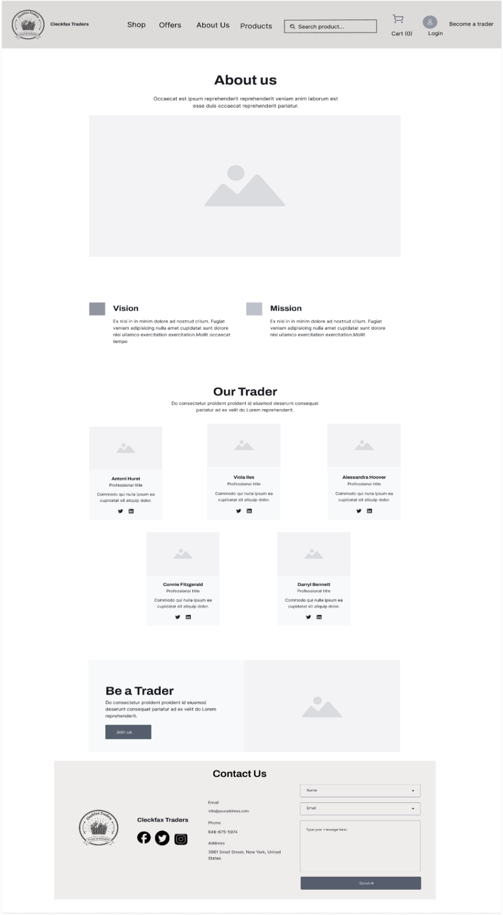

### Add Trader

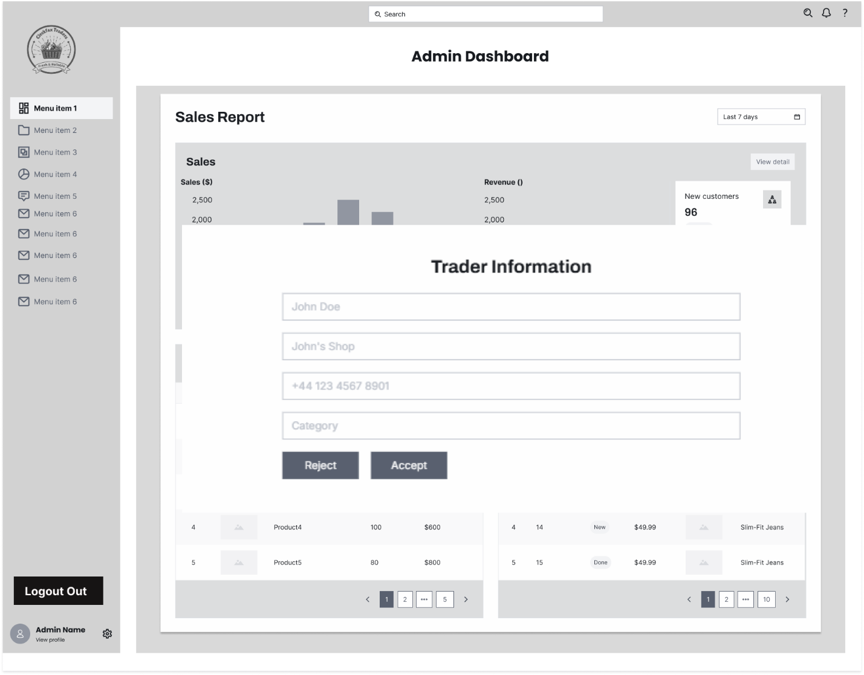

### Admin Dashboard

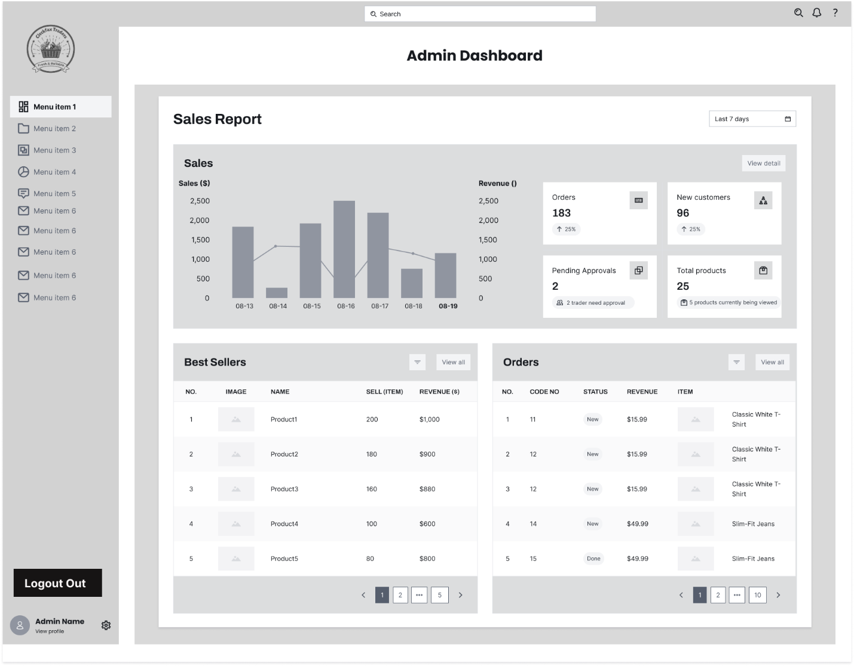

### Cart

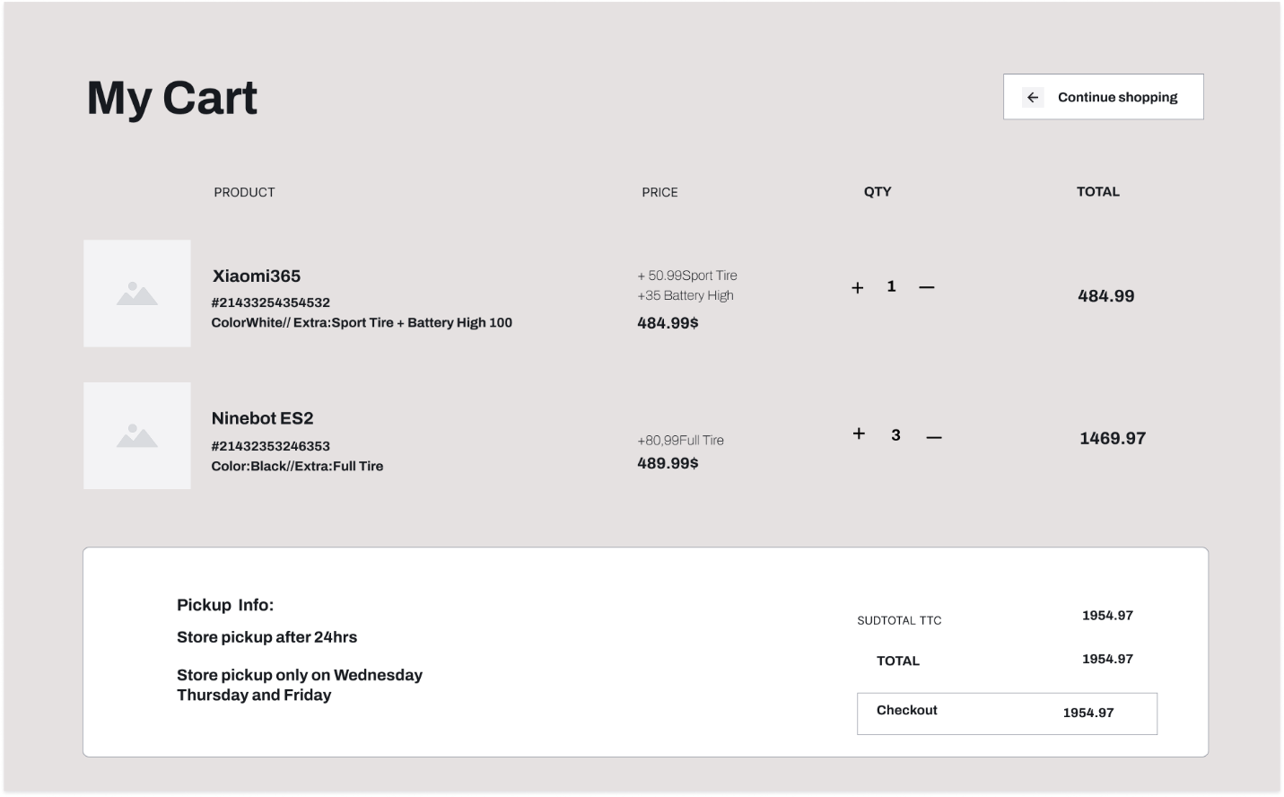

### Customer List

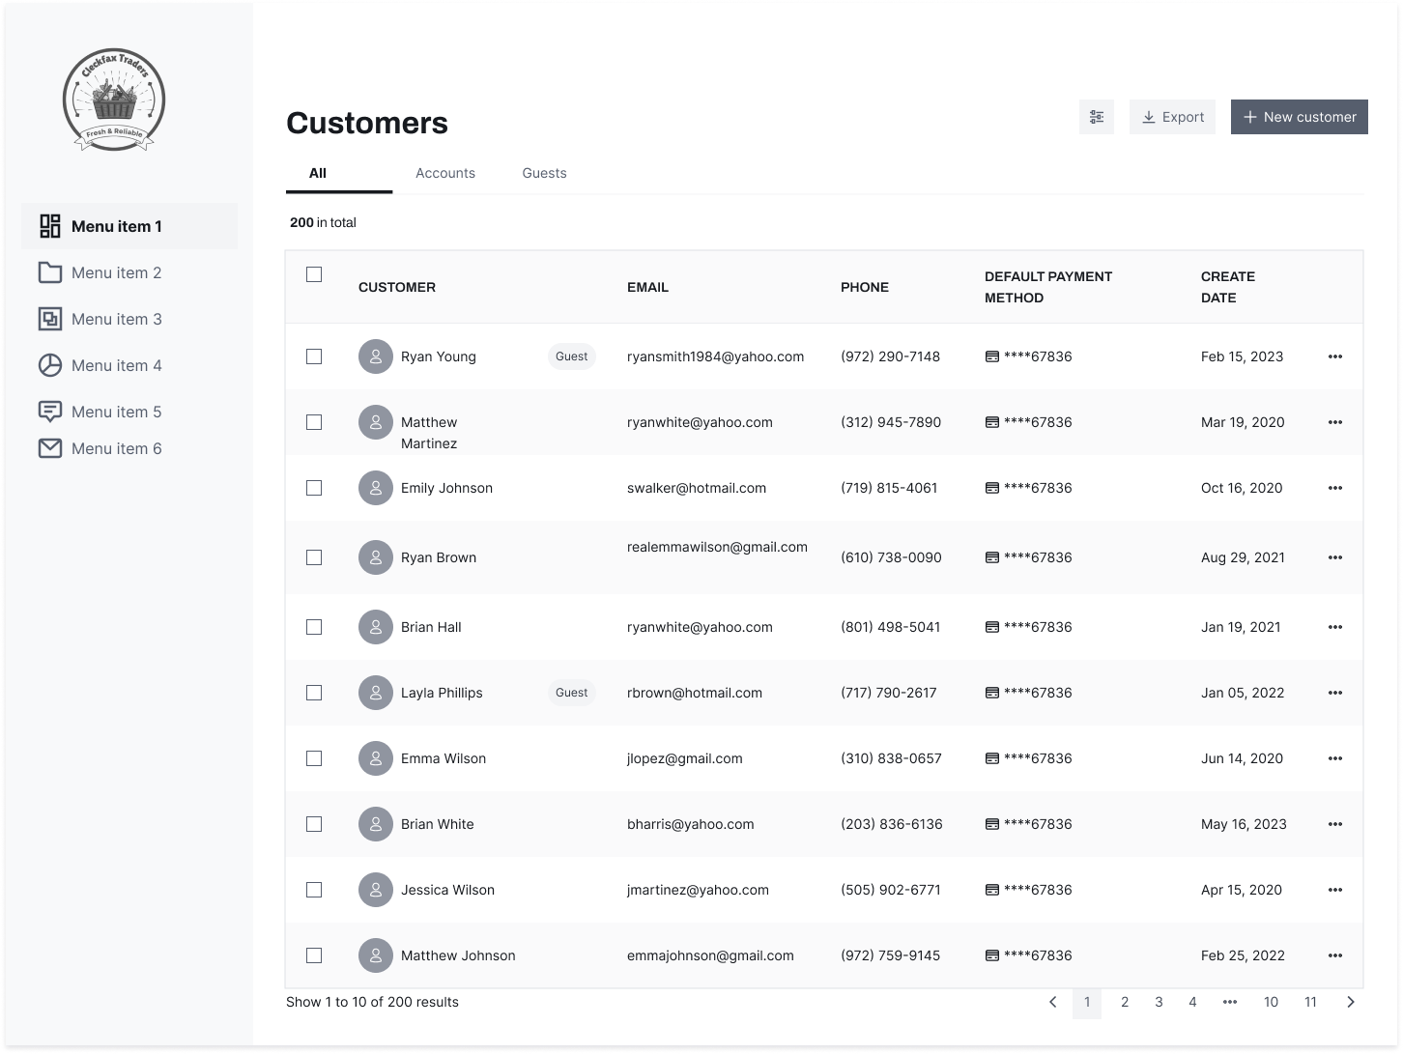

### Customer Profile

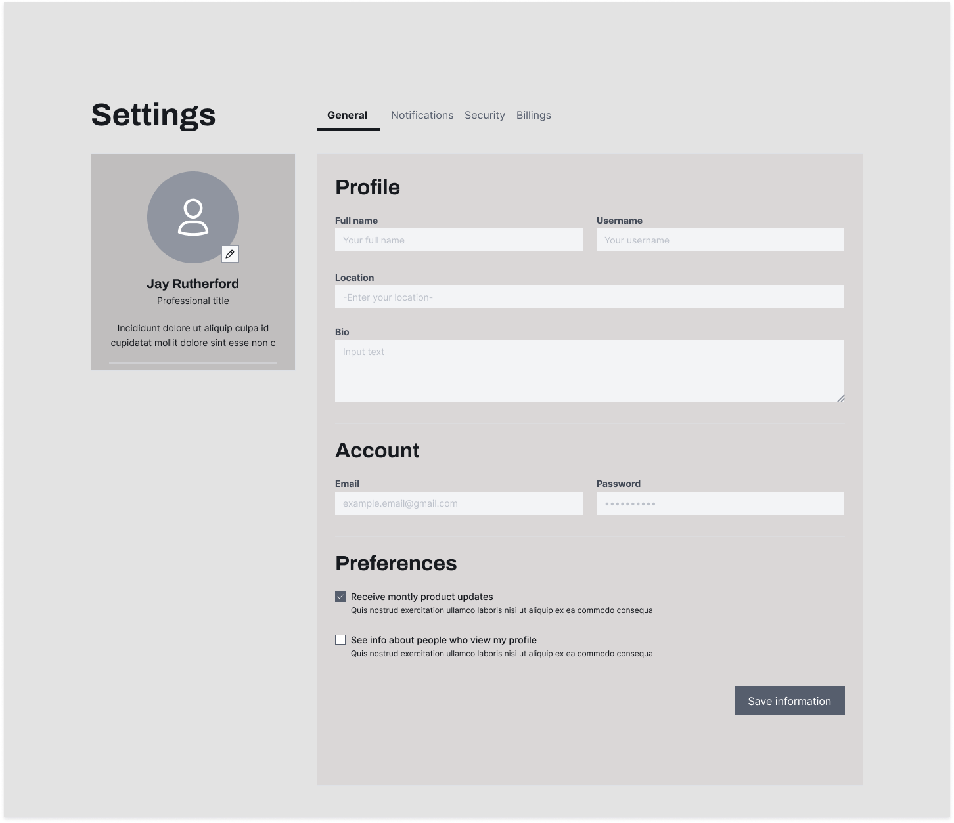

### Footer

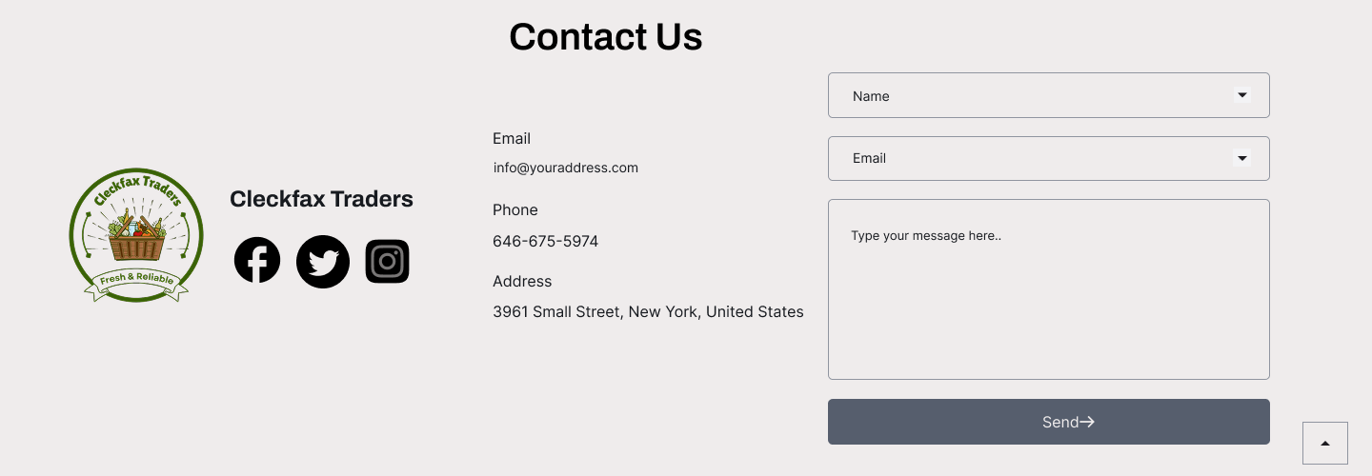

### Invoice

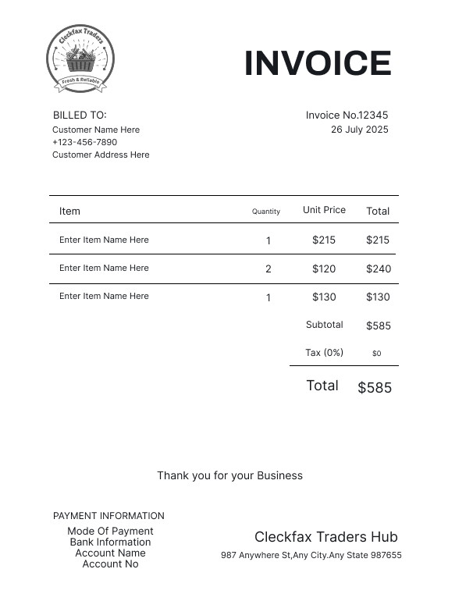

### Landing Page

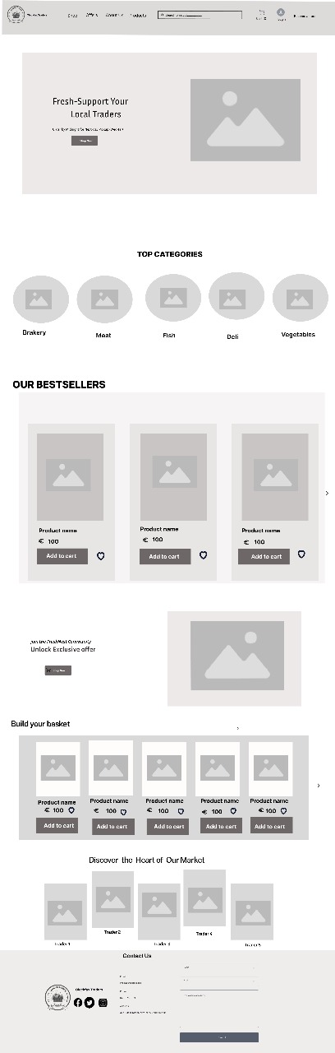

### Login

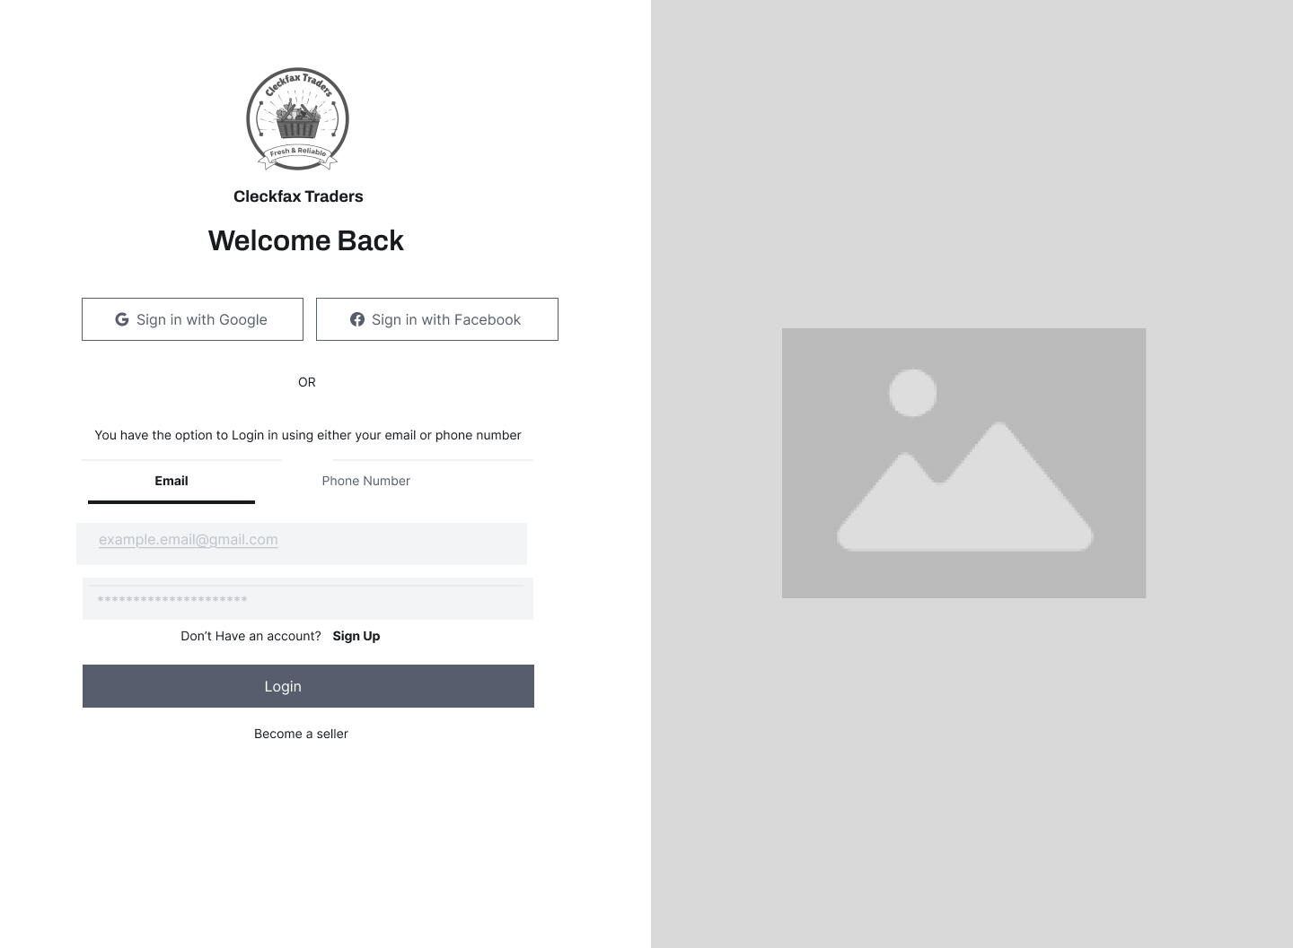

### Navbar



### Product Detail Page

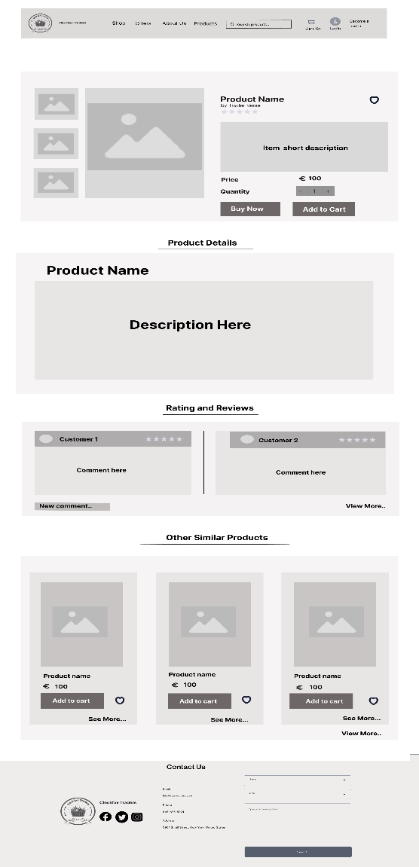

### Product Inventory

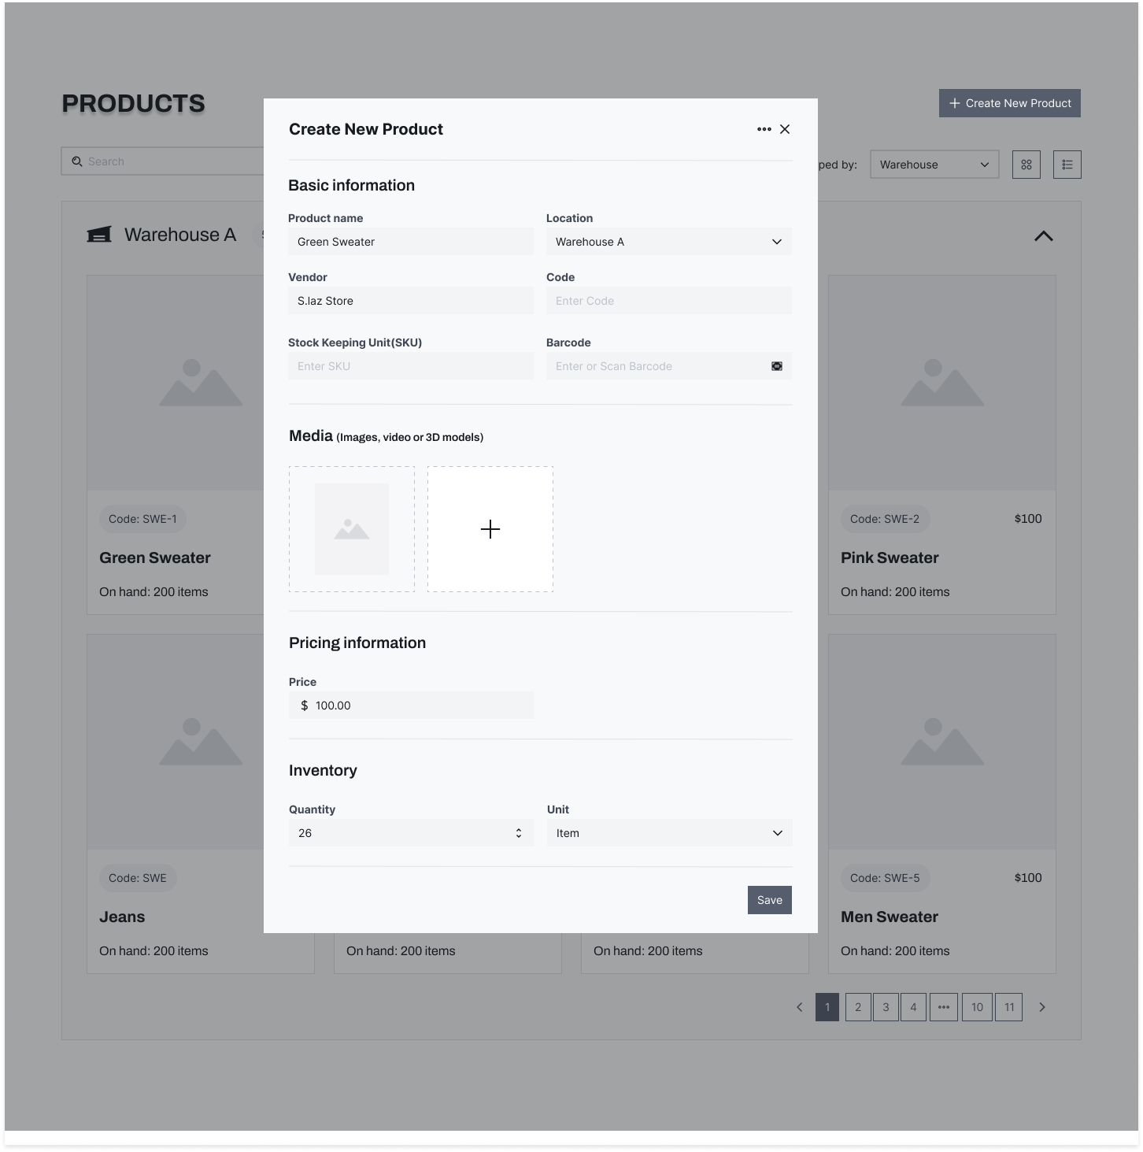

### Product Inventory(Trader)

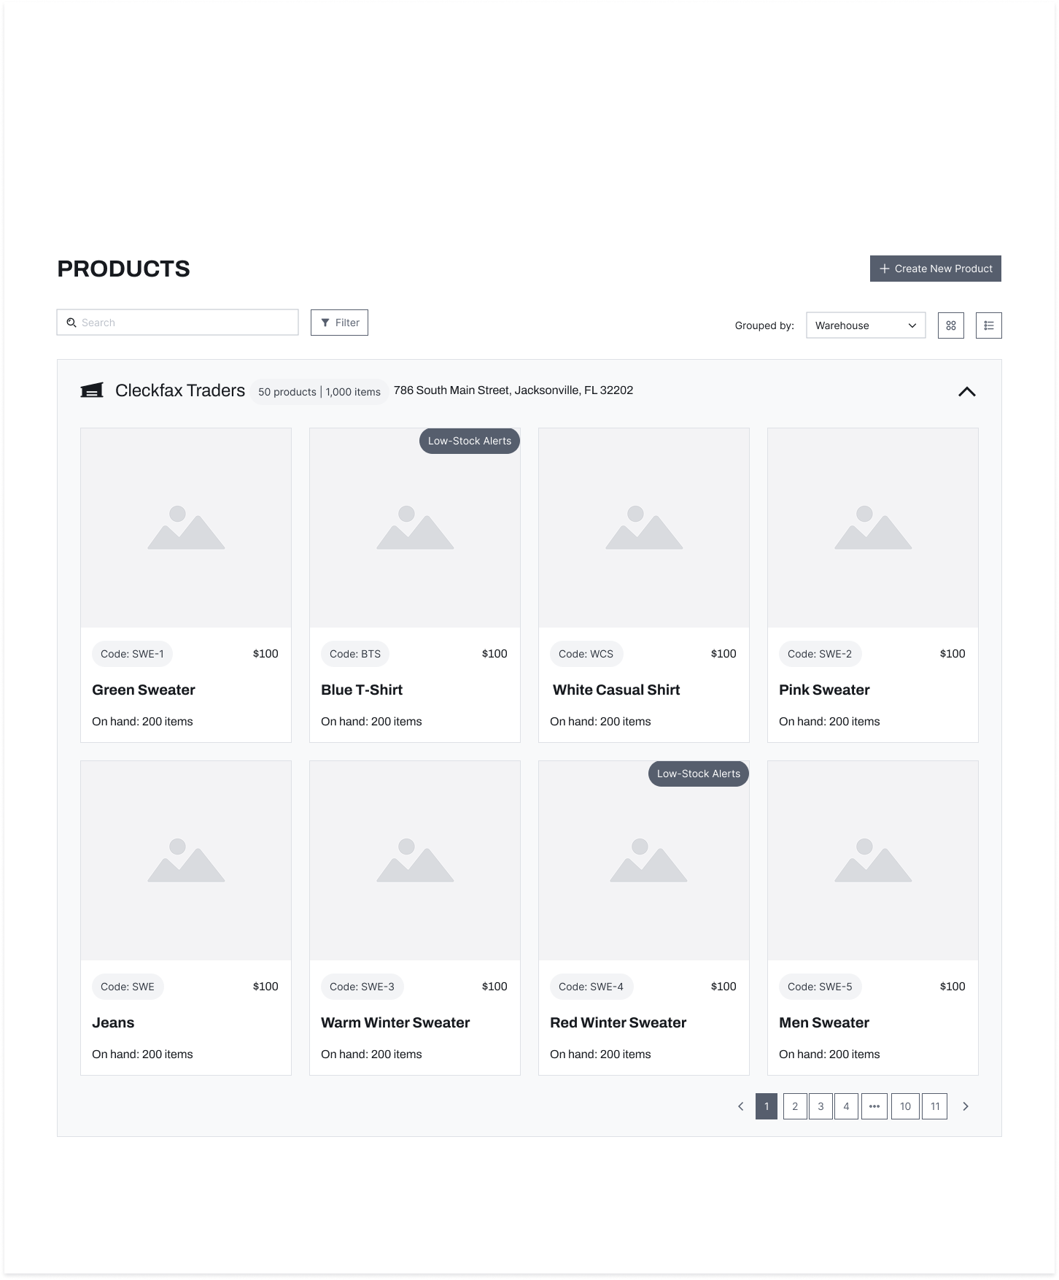

### Product Listing(Customer)

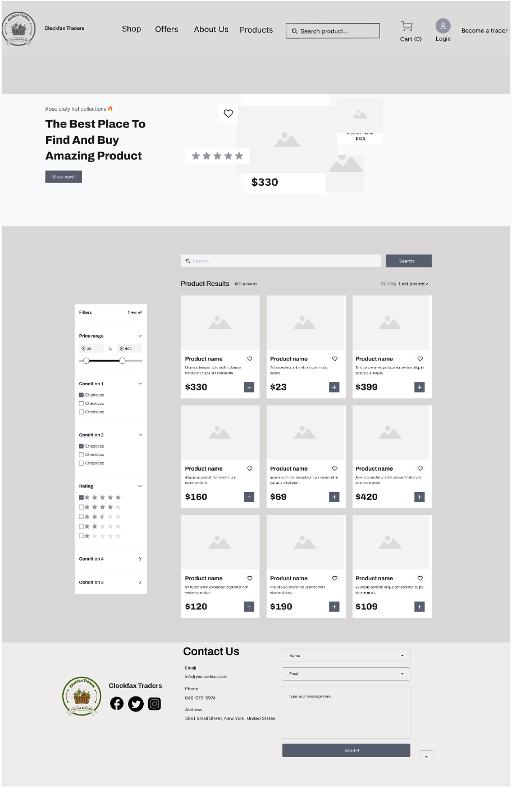

### Trader Dashboard

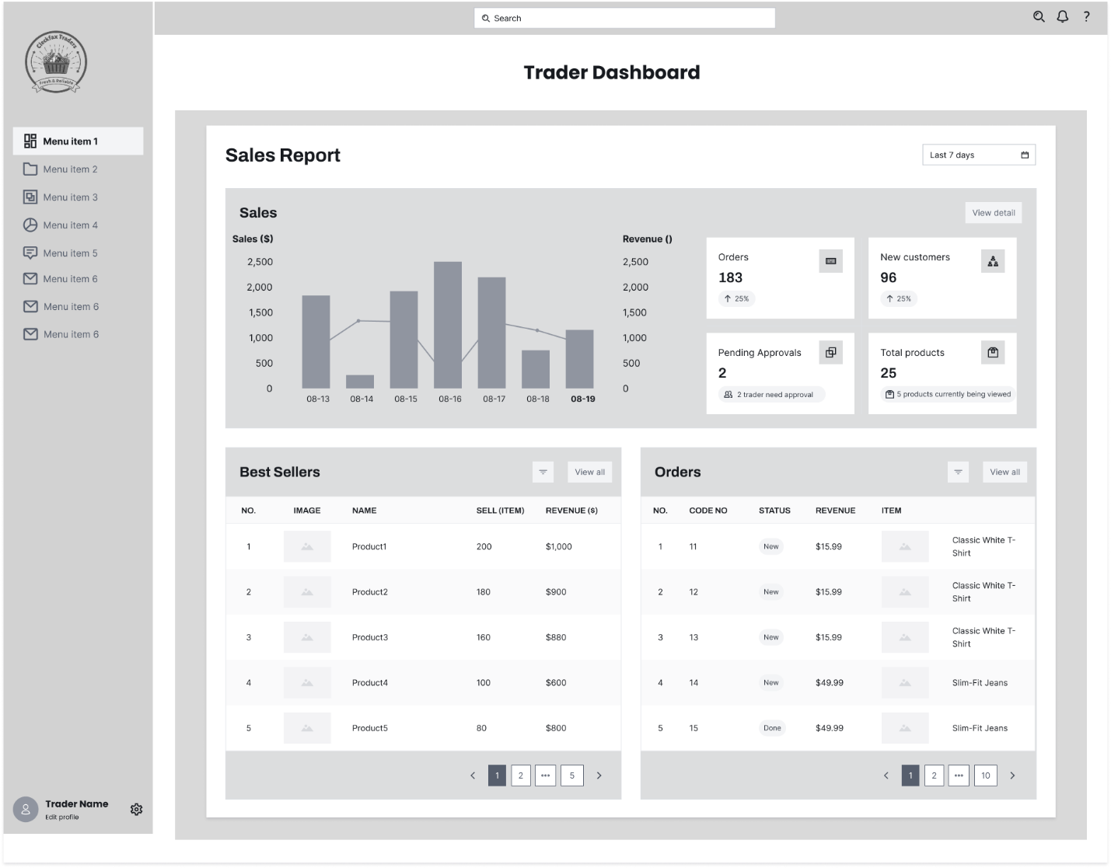

### Trader Product List

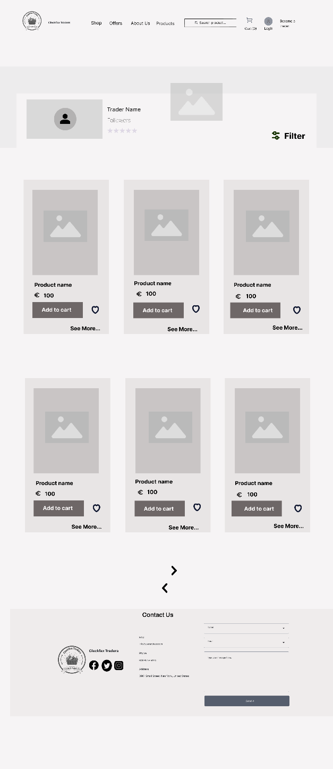

### Trader Register

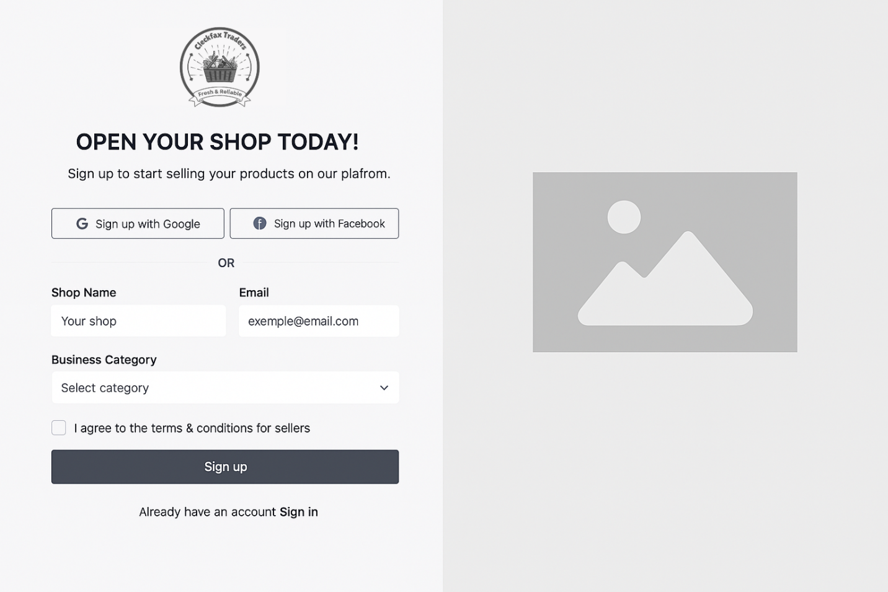

### User Register

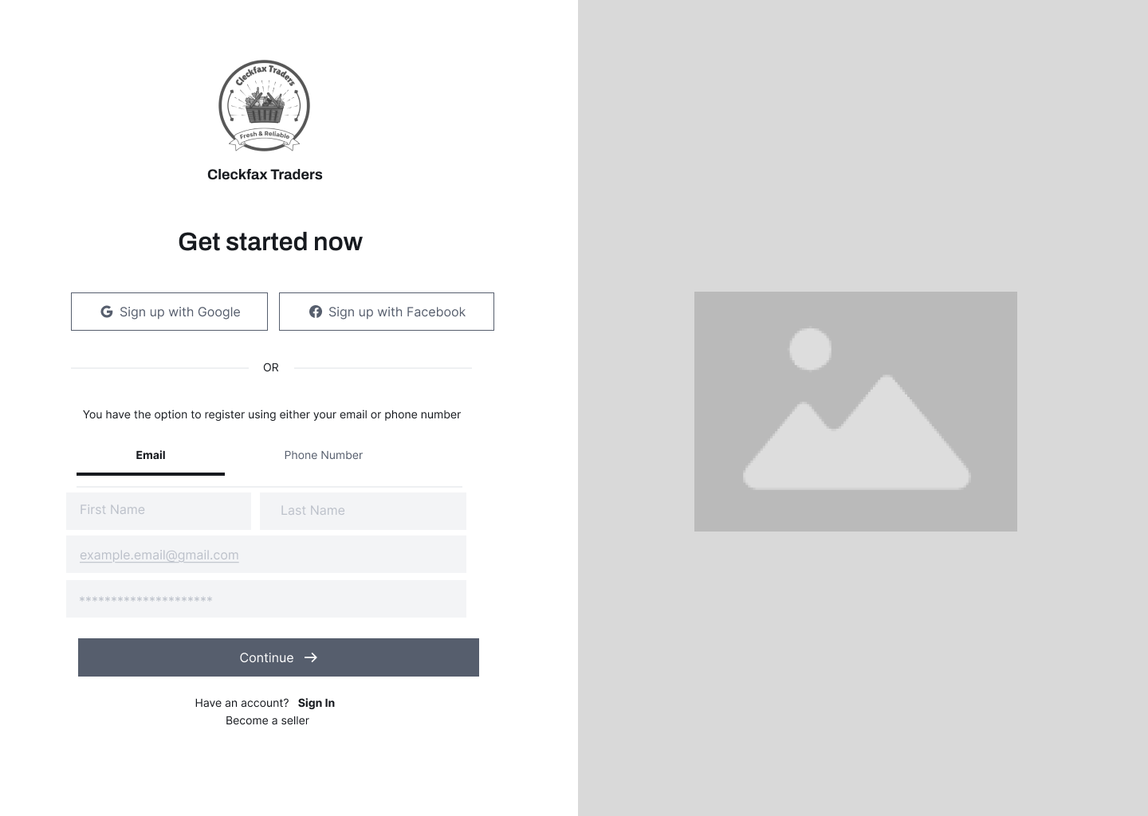

### Verification

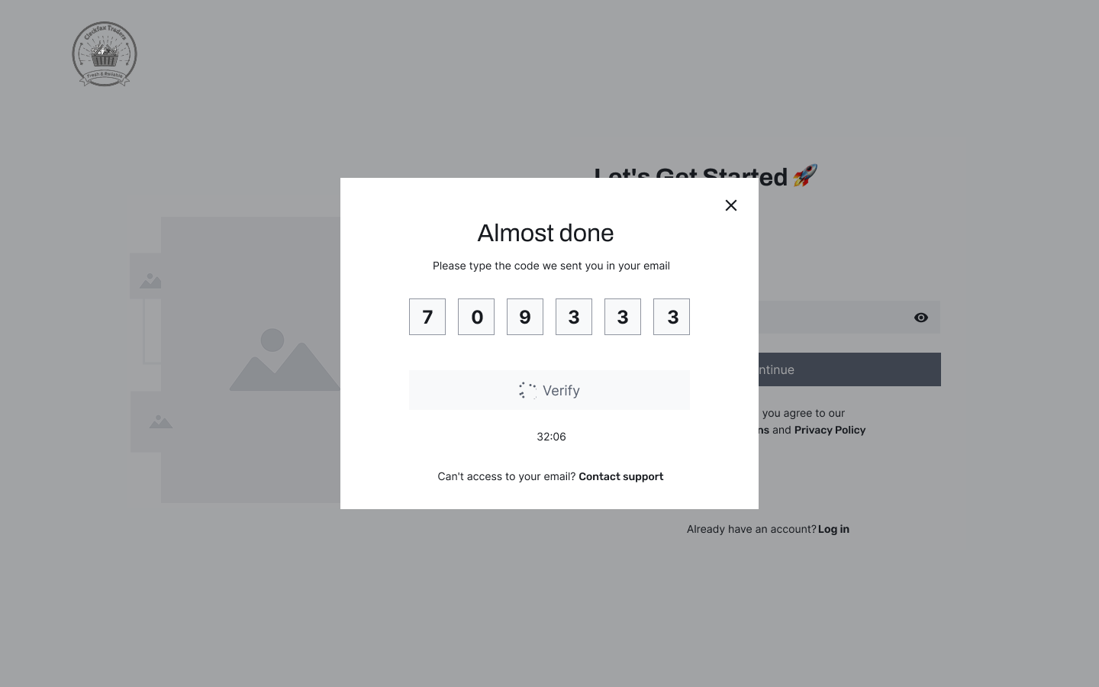

# Product Development

## Screenshots

1.Home Page

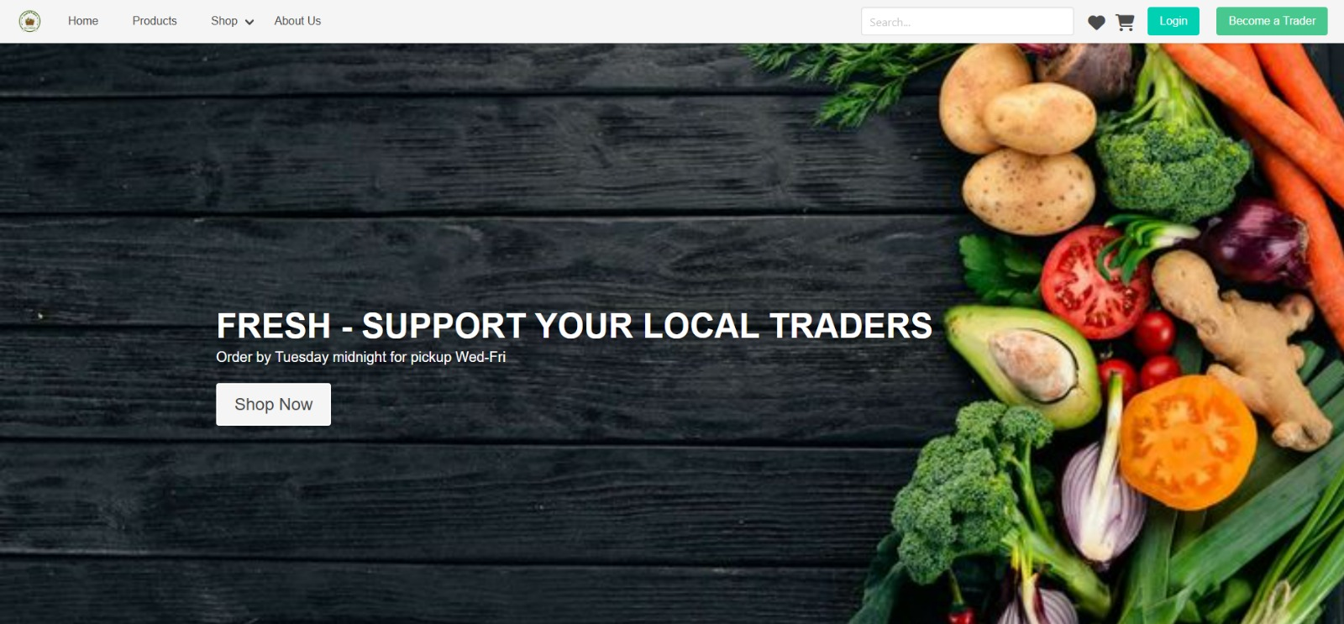

2.Sign up page

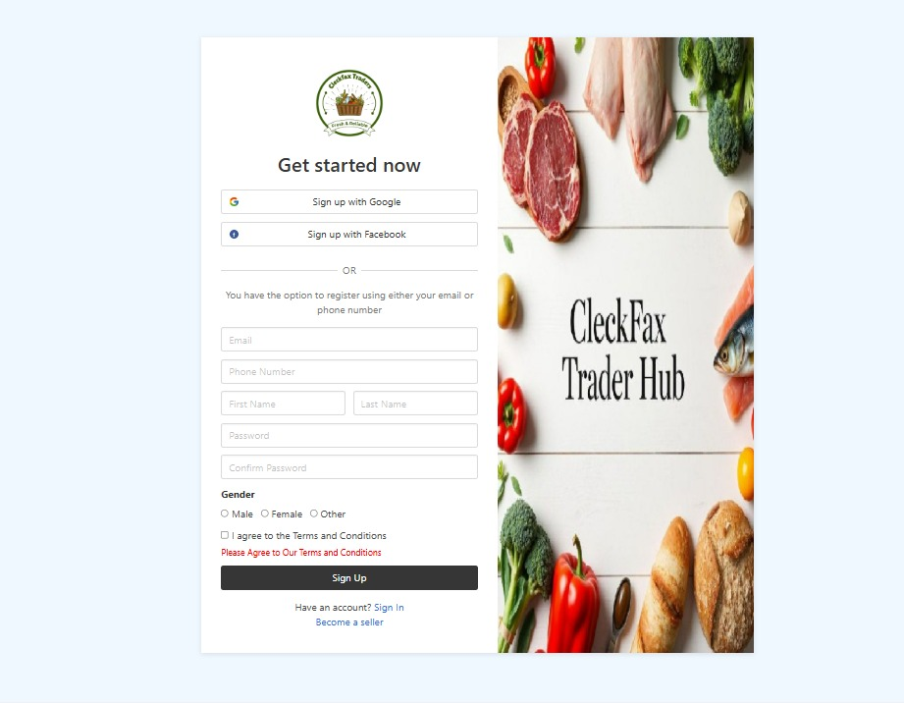

3. Sign in page

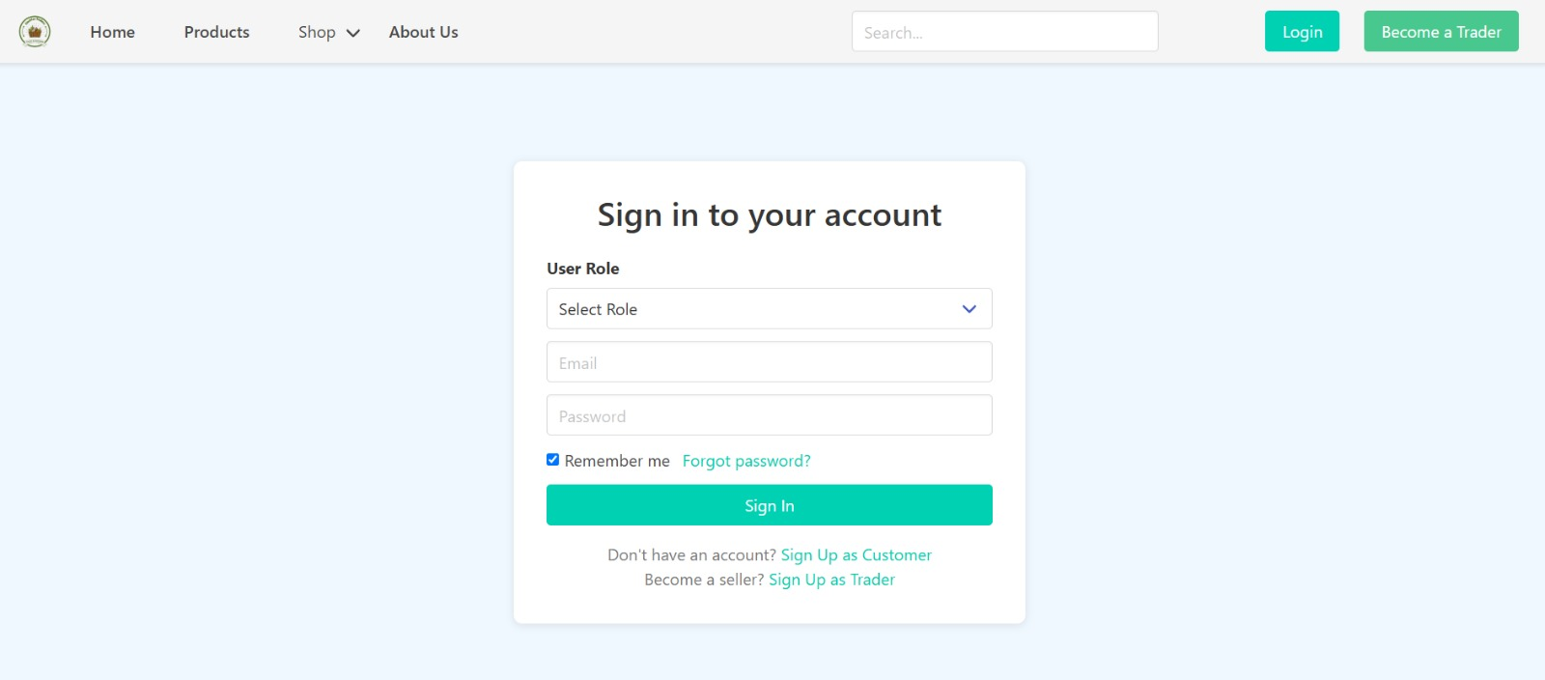

4.Product list

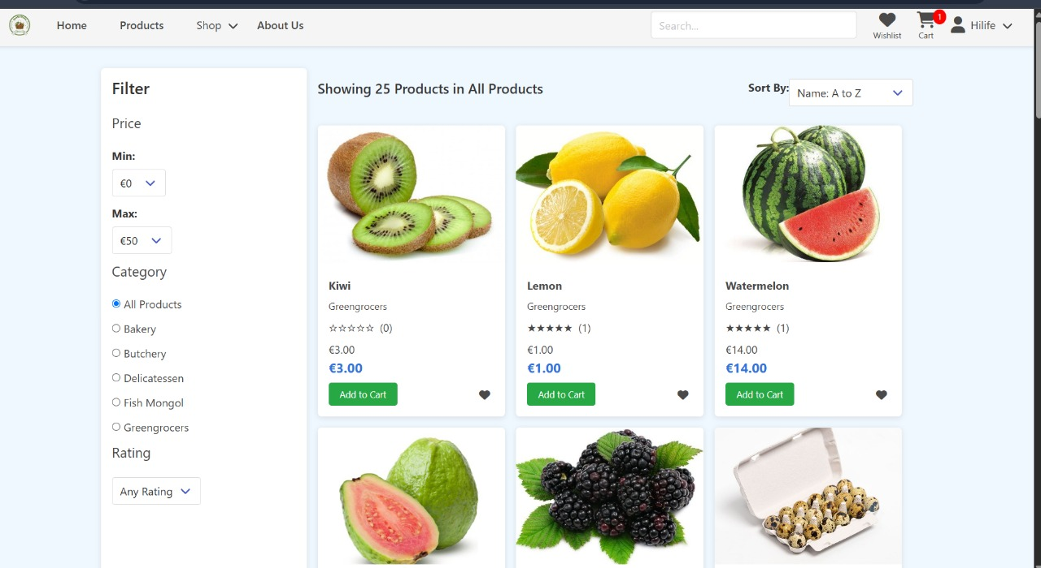

5.Product Detail

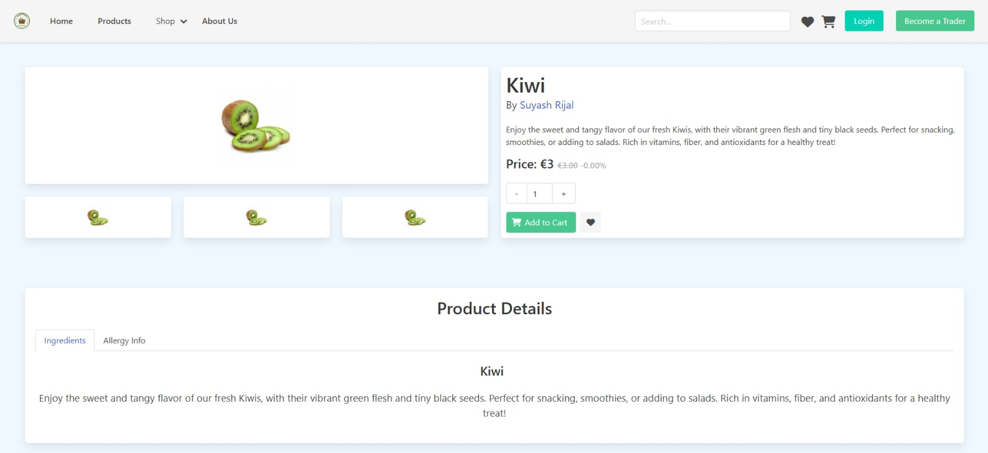

6.About us

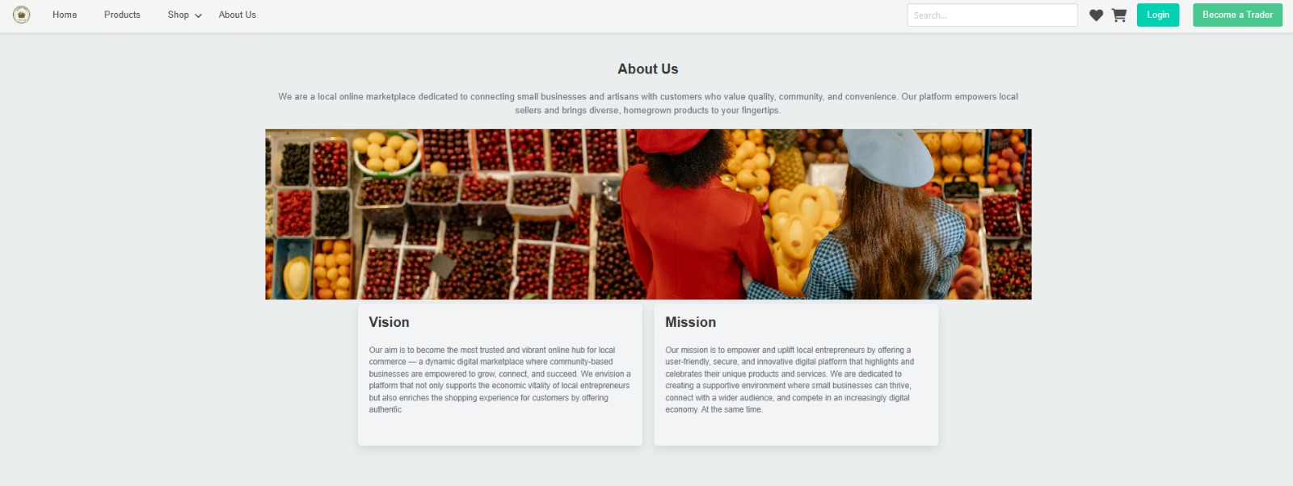

7.Rating and review

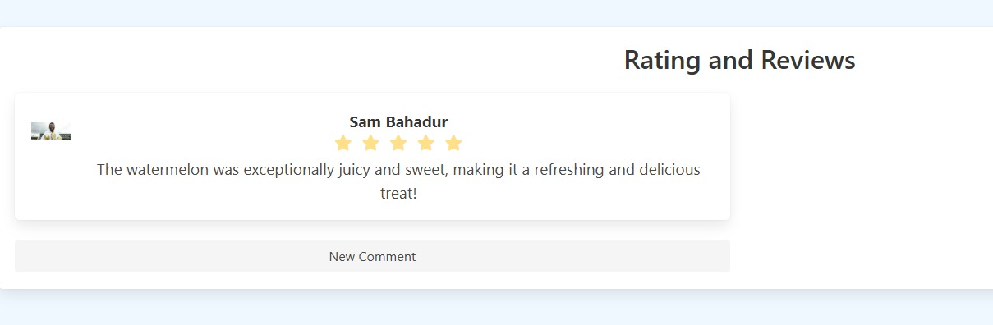

8. Search

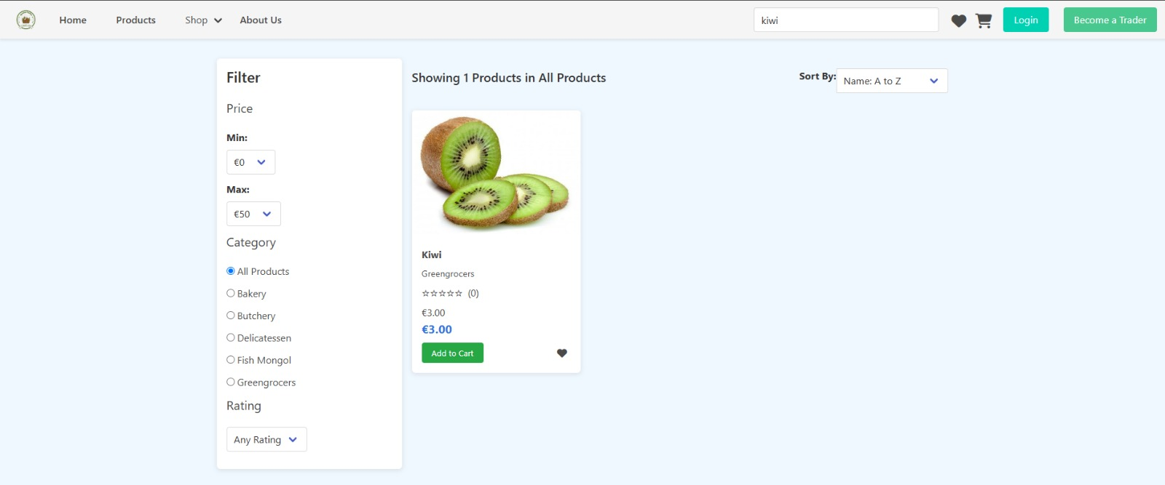

9.Wishlist

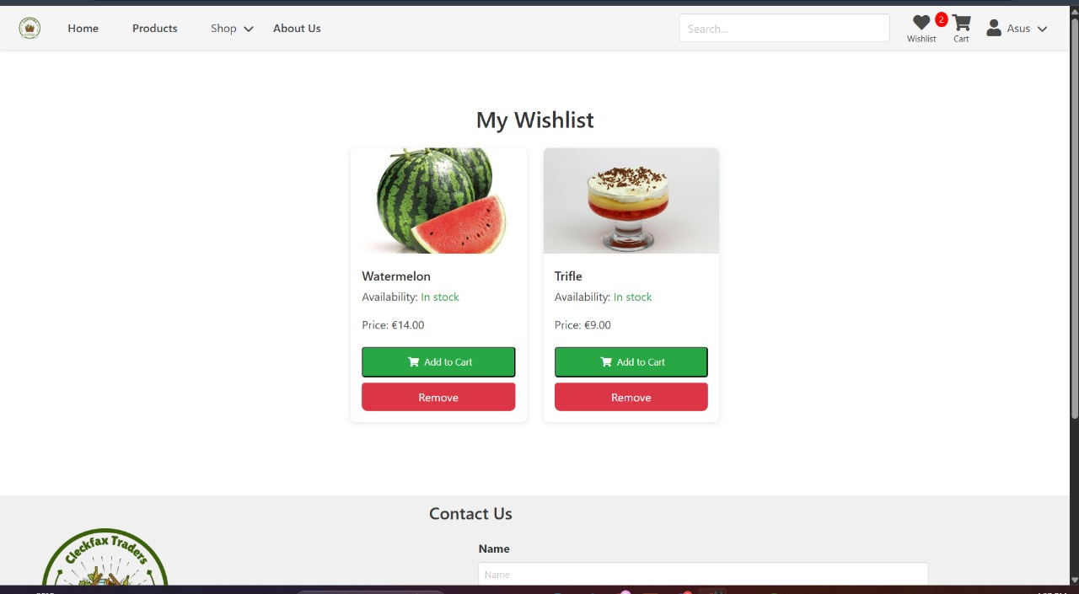

10.Cart

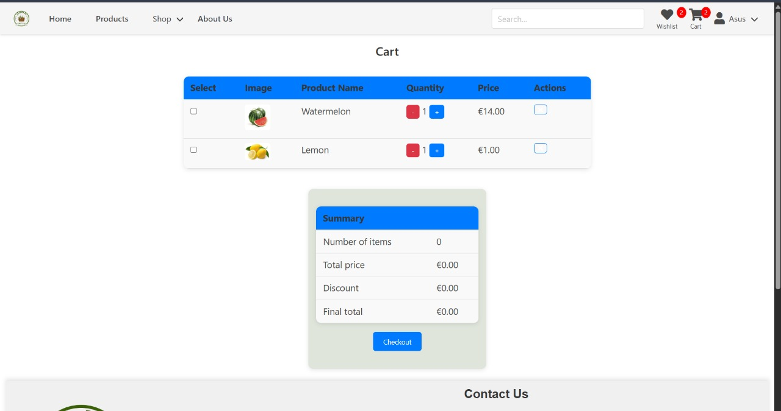

11.verification

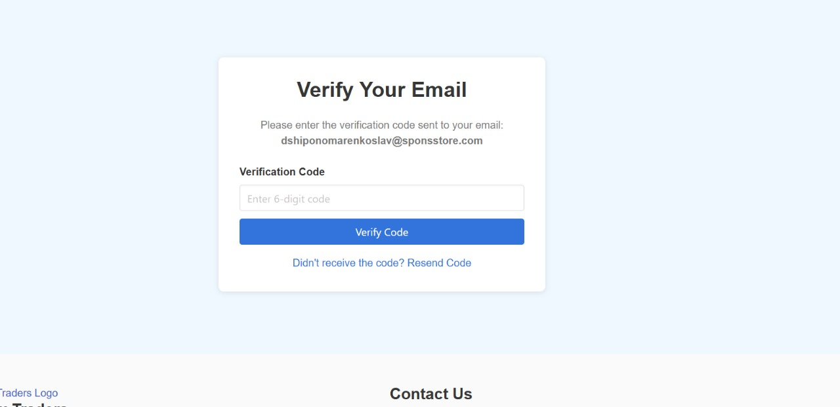

12.Paypal

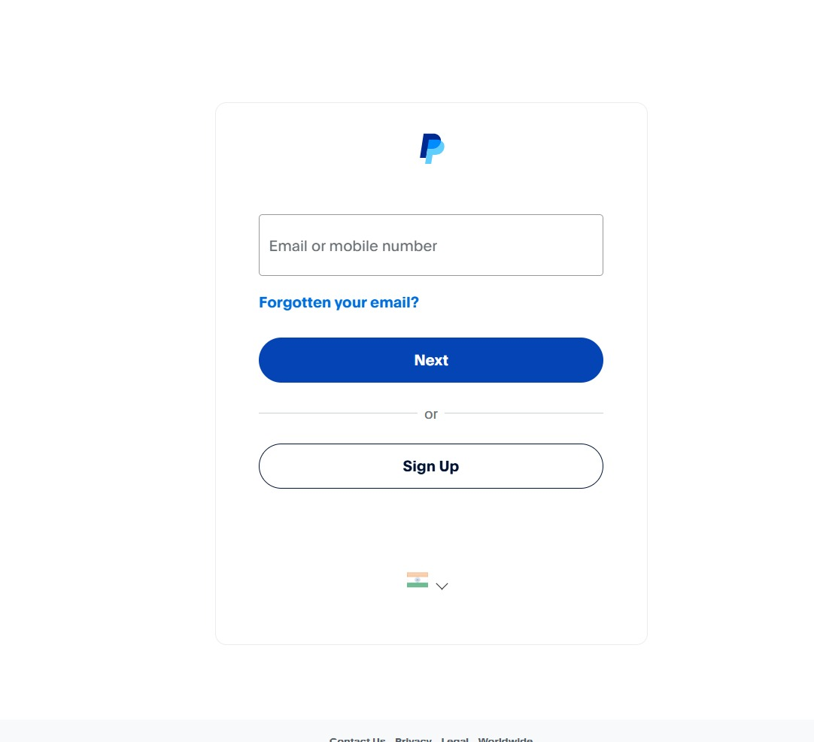

13.Admin sign up

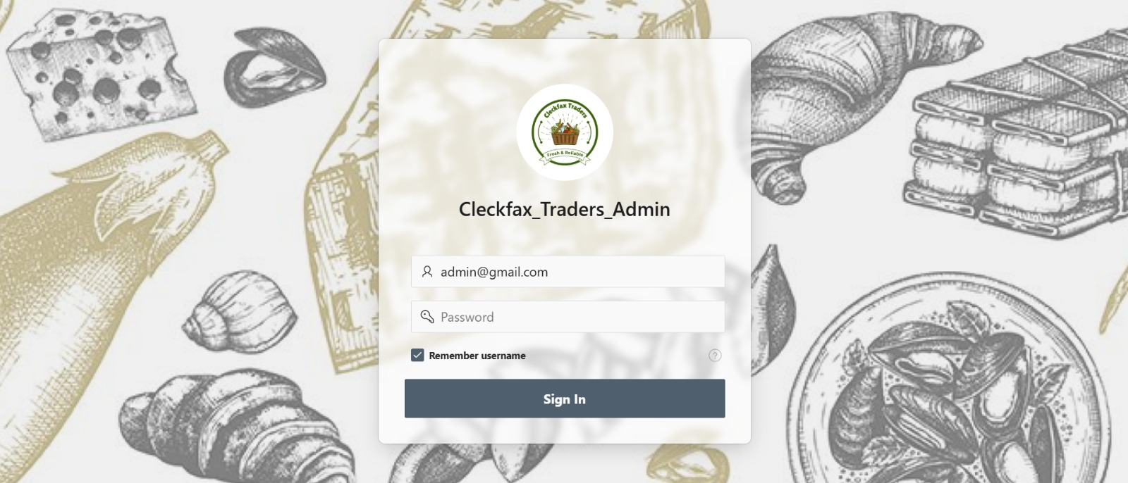

14.Trader Dashboard

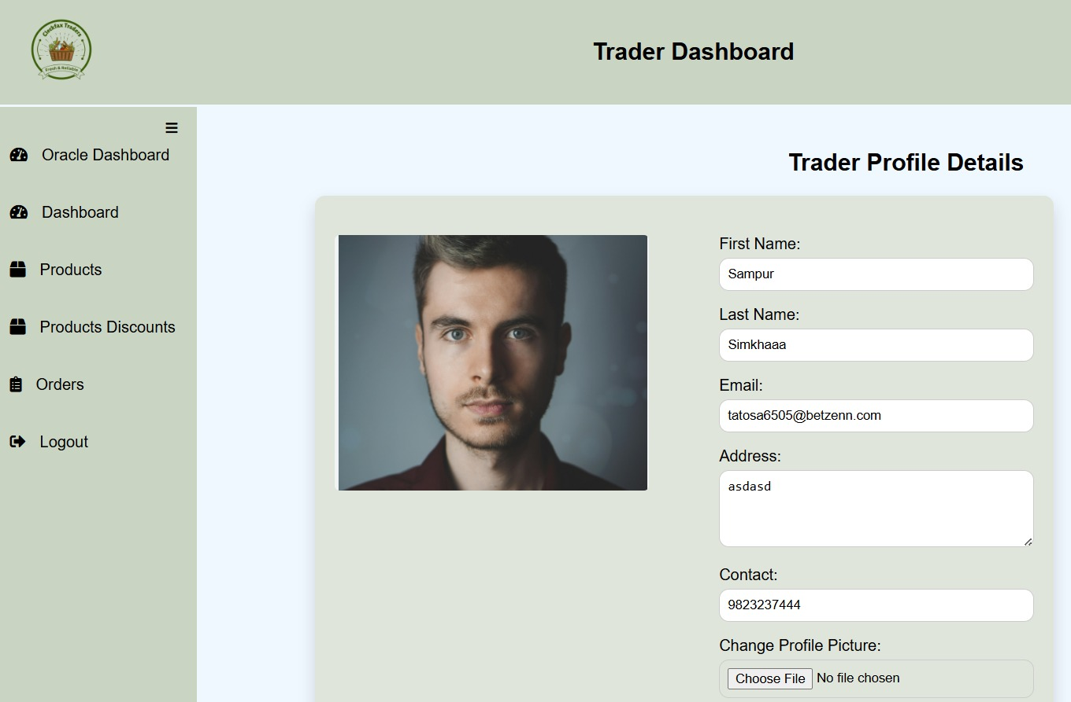

15 Thank you

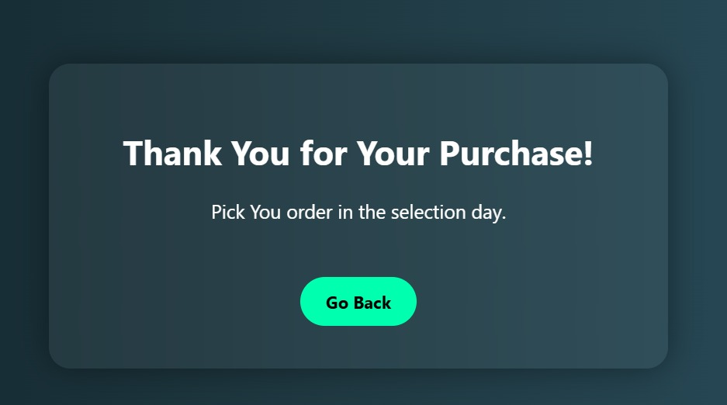

## Homepage

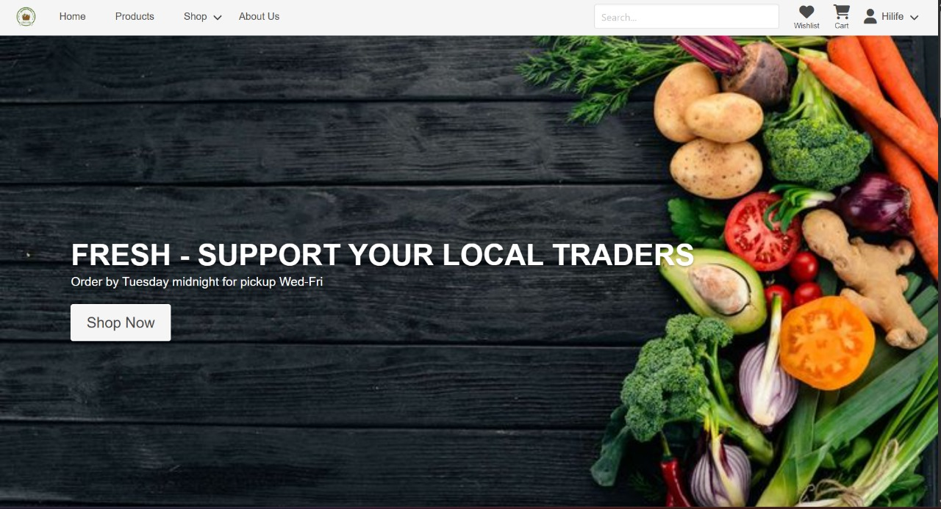

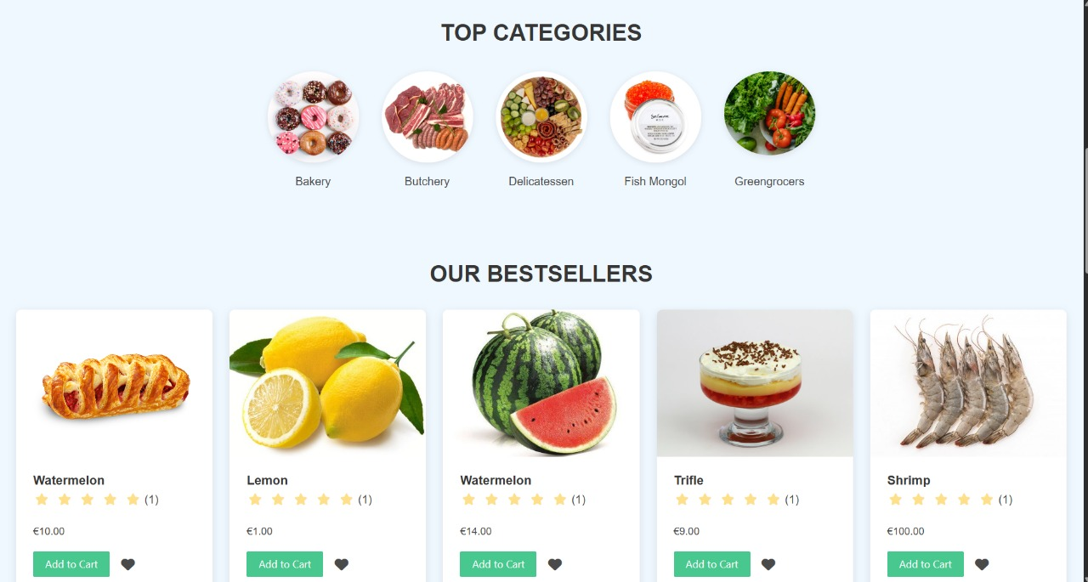

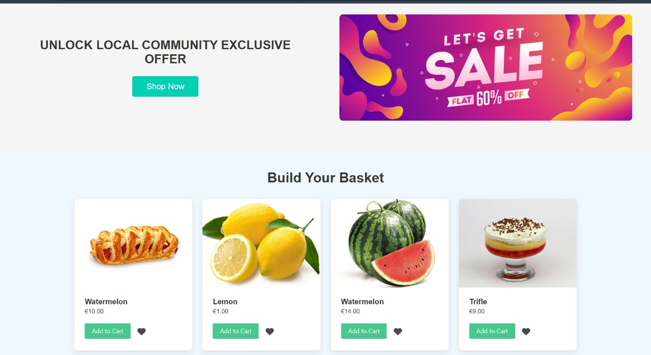

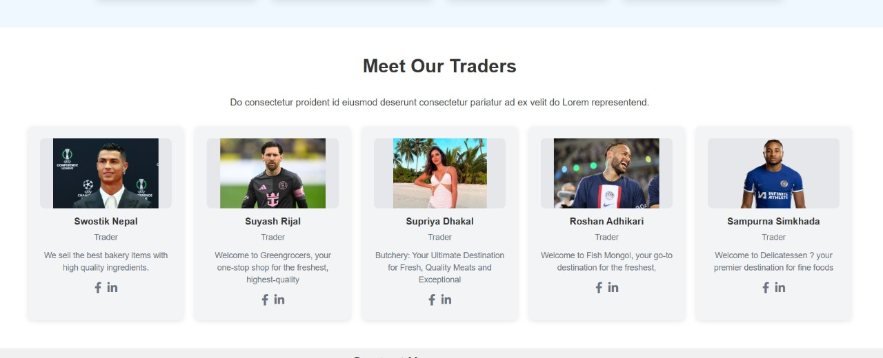

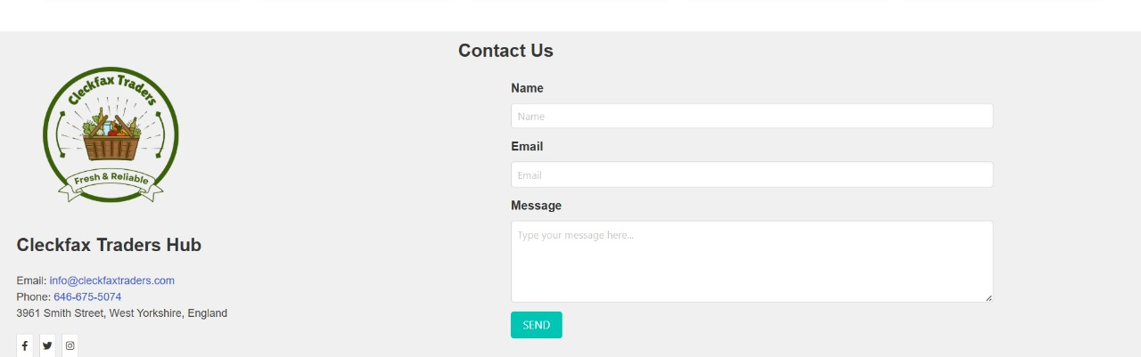

# Product Testing

## Customer interface testing

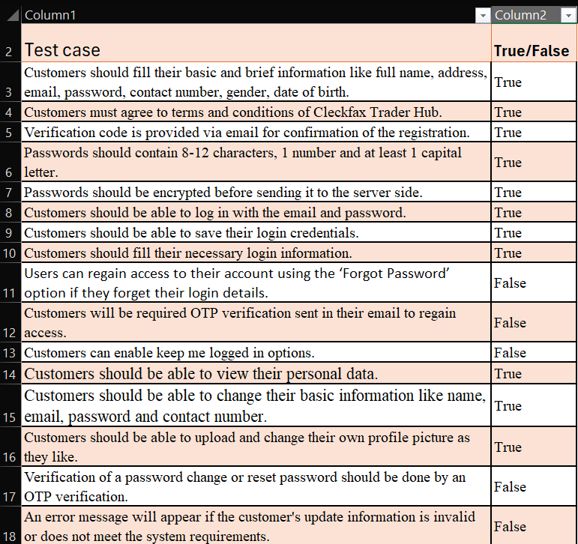

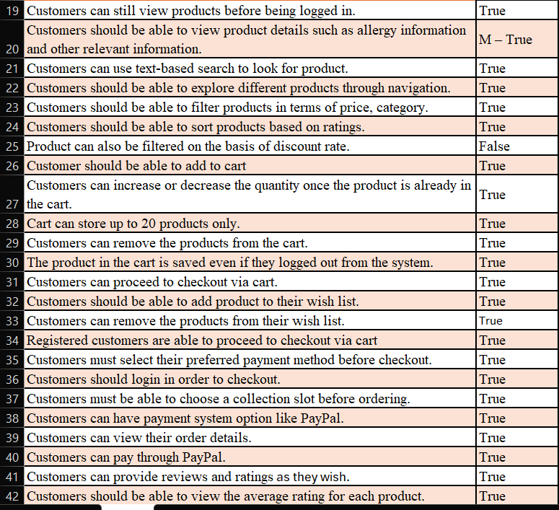

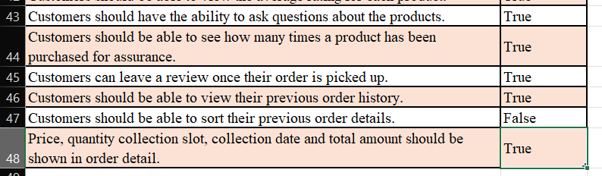

## Trader interface testing

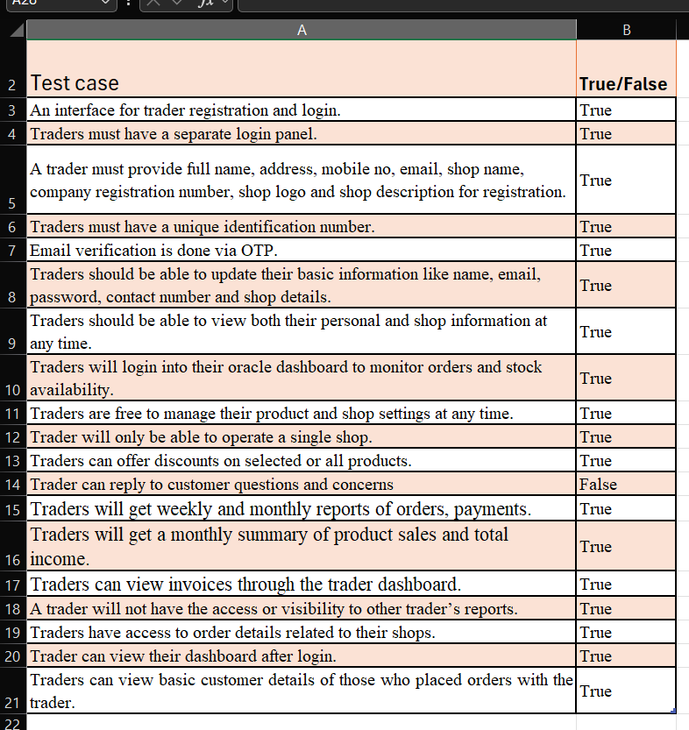

## Admin Interface testing

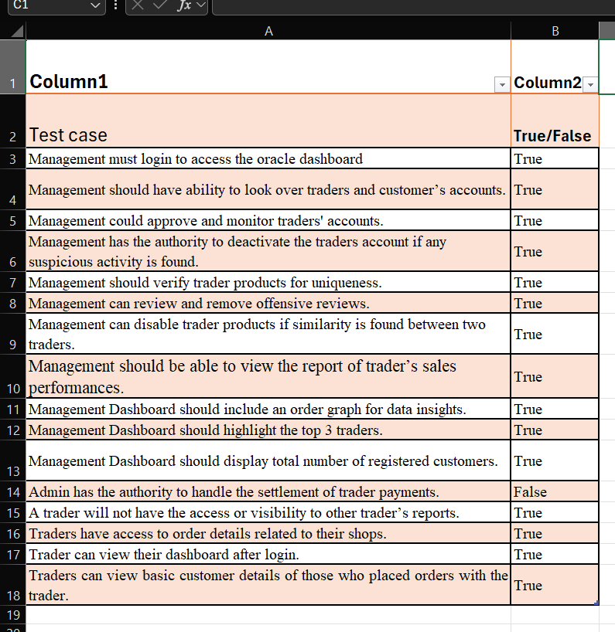

# Frequently Asked Questions

1. What is Cleckfax traders hub.com?

- Cleckfax traders hub.com is a collaborative e-commerce platform created by local grocery traders in Cleckfax traders hub. It provides a seamless online marketplace where customers can browse, select, and collect fresh goods from various shops in one place. The goal is to modernize local shopping while preserving the convenience of traditional grocery shopping.

2. Why use our service?

- Cleckfax Traders Hub is designed for people with busy schedules who need a fast, convenient, and secure way to shop for groceries. The platform offers:

Access to a variety of local shops in one place,

Filter and search features to find products easily,

Secure payments via PayPal,

Collection slot selection,

Review and feedback system, and

A user-friendly experience whether logged in or not.

It supports local businesses and helps customers avoid the hassle of visiting multiple stores.

3. Can I return an item?

- No, since Cleckfax Traders Hub sells fresh items that are perishable, returns are not accepted. However, if you are not satisfied with a product, you are encouraged to post a review or feedback. Traders and platform admin monitor these reviews to ensure continuous quality improvement.

4.Can I leave a review even if I’m not satisfied with the product?

- Yes. Customers can rate products, leave feedback, and raise issues through the review system. Traders can respond to feedback to maintain service quality, and the admin monitors reviews to ensure accountability.

5. Do I need to create an account to shop?

- No, customers can browse and explore products without creating an account. However, registration and login are required for actions like adding items to a cart, checking out, and leaving reviews. Registered users also benefit from features like cart retention, order tracking, and personalized experiences.